INVESTIGATION OF THE POSSIBILITY TO PREVENT BROWN COLOUR FORMATION IN GROUND WATER USING BIOMATERIAL

R.P.C. Iroshini¹, M. Thayaparan², M.D.J.S. Saparamadu²*

ACE Healthcare (pvt) Ltd, Horana ¹, Department of Chemistry, The Open University of Sri Lanaka

INTRODUCTION
In Chavakachcheri (Jaffna district), an unpleasant metallic odor, taste and reddish-brown colour in water have been observed in some shallow and tube wells but not in shallow wells when deepened into tube wells. When clear water was drawn out from tube wells, the colour was developed with time. The coloured drinking water, stains on washed clothes etc. has created economic problems. Colour in water may be due to several reasons but this research was limited to the possible inorganic substances- iron and manganese (Research committee report, 1967). Rainwater dissolves iron and seeps into groundwater sources of wells. Iron is mainly present in water as Fe²⁺ or Fe³⁺. High K_{sp} of Fe (OH)₂ (4.87 × 10⁻¹⁷ mol³dm⁻⁹ at 25º C) prevents precipitation of Fe²⁺ but when oxidized by dissolved oxygen to Fe³⁺ it forms a reddish-brown colour Fe (OH)₃ (K_{sp} 2.79 × 10⁻³⁹ mol⁴dm⁻¹² at 25º C). Anaerobic groundwater often contains high levels of dissolved Mn. Mn²⁺predominates in most water at pH 4 –7 and undergo oxidation forming a black precipitate (Research committee report, 1967). Decomposition of organic matter causes depletion of oxygen in the water. Conditions of wells (depth, width, surrounding situation, soil composition), climatic conditions (temperature, humidity, rain-fall pattern), pH and dissolved oxygen (DO) affects the composition of inorganic substances in water. Bio-sorption is a physio-chemical process used to remove colour (Volesky, B.,1990). The objective of this research was to investigate the possibility of using bio-sorption to prevent or remove the brown colouration of water and to optimize the ability. The selection of charcoal of rice husk and coconut shell as bio-sorbents were based on availability and cost.

METHODOLOGY
Coloured (C) and non-coloured (NC) water samples from 7 and 5 locations respectively were collected from 1 km² area in Chavakachcheri during the dry season in August 2018 between 7.00 a.m. to 12.30 p.m. Water samples were stored according to the accepted guidelines (American Public Health Association, 2005). All chemicals used were of Reagent and AAS Grade. Distilled water was used for preparation of solutions. pH (with temperature), odor and colour were measured insitu using a pH meter (Extex), sensory evaluation and Nesslerizer apparatus (MSSLE-2150) respectively (American Public Health Association, 2005). Electrical conductivity and turbidity were measured using conductivity meter (Orion 3- star plus) and turbidity meter (Orion AQ 4500) within 24 hours after sample collection (American Public Health Association, 2005). DO, COD and alkalinity were analyzed using Winkler method, Open reflux method and titrimetry respectively (American Public Health Association, 2005). Coloured (1000 mL) sample was centrifuged and the precipitate was dissolved in dil. HNO₃. Qualitative analysis were carried out for filtrates and the precipitate. Water samples were analyzed quantitatively for chloride by Argentometry, sulphate by Turbidimetry and total iron as Fe³⁺ by Thiocyanate Visible spectroscopic method (American Public Health Association, 2005).100 ppm of stock Fe³⁺ (diluted AAS grade stock iron solution) and Fe²⁺ solutions {by dissolving FeSO₄ (0.2722 g) in 500 mL distilled water containing conc.H₂SO₄ (5.0 mL) and made up to 1000.0 mL} were prepared. Washed and sundried coconut shells (for one week) were burnt in a drum for 3-5 hours and charcoal (CCS) was ground and passed through a sieve (600 μm pore size). Dried rice husks were burnt in a drum for 24 hours and charcoal of rice husk (CRH) was passed through a sieve (212 μm pore size). In pH studies, solutions of 0.5, 2.0, 4.0, 6.0, 8.0 ppm of Fe²⁺ and Fe³⁺ were prepared separately and pH were varied from 1-10 by adding dil. NH₄OH and dil. HNO₃ and the colour development was observed. For preliminary bio-sorbent studies, 25.0 mL of 7 ppm Fe²⁺ and Fe³⁺ solutions were used separately, and the solutions were equilibrated using the mechanical shaker (100 rpm) followed by filtering (Whatman No.01 filter paper). The total iron as Fe³⁺ of the original samples and the filtrates were determined by Thiocyanate Visible spectroscopic method. For weight optimization, different weights of the bio-sorbents (0.025 g- 0.75 g) were equilibrated for 30 minutes. For time optimization, the optimum weights of the bio-sorbents were equilibrated for different time periods (1, 3, 5, 8, 10, 15, 20 min.). Since the filtering took 1min., samples were taken from the shaker 30 seconds before the set time to filter. In the investigation of the possibility of prevention of colour formation by prepared bio-sorbents, the same above experiments were carried out with optimal weight of each bio-sorbent at pH 4.0 equilibrating for 10 minutes. The findings were applied to natural tube well water samples (50.0 mL) of Chavakachcheri area before formation of colour. All experiments were carried out in triplicate.

RESULTS AND DISCUSSION:
Table 1: Physical parameters of coloured and non-coloured water of wells
Parameters | Coloured water (C)  (meanSD) | Non- coloured water (NC) (meanSD) | Requirement  (maximum)
pH | 7.15 0.08 | 7.98 0.39 | 6.5-8.5
Electrical conductivity | 2177 182 | 1638 60 | 750
Turbidity (NTU) | 24.2 13.1 | 0.54 0.60 | 2
Total Alkalinity (mol/ L) | 266 41 | 253 63 | 200
COD (O₂ mg / L) | 7.4 2.1 | 3.5 1.2 | 10
Dissolved Oxygen (ppm) | 3.771.75 | 5.383.38 | 30

High DO in NC-water compared to C-water (Table 1) implies that O₂ in C-water has been utilized for the formation of coloured compound. The total iron content in the C-filtrate, C- precipitate, C-unfiltered sample and NC-filtrate was (ppm) 0.2, 6.2, 6.6 and 0 respectively. In addition, SO₄²⁻ (103 ppm) and Cl⁻ (486 ppm) in the filtrate of C and SO₄²⁻ (326 ppm) and Cl⁻ (75 ppm) in NC were found indicating that the colour forming cation is Fe³⁺ and it is precipitated as Fe (OH)₃.

Identification of the maximum [Fe²⁺] and [Fe³⁺] which do not form observable colour with pH
Precipitation can occur when [Fe³⁺] is low with high [OH⁻] and vice versa. Therefore, we need to find the [Fe³⁺] which will not form Fe (OH)₃ even with high pH. Since Fe³⁺ can be reduced to Fe²⁺ and vice versa, we considered the total iron concentration. Therefore, we carried out this study for both Fe²⁺ and Fe³⁺. [Fe²⁺] was determined after oxidizing to Fe³⁺ by adding KMnO₄ followed by Thiocyanate Visible spectroscopic method. The results showed that when [Fe³⁺] was decreased to < 2 ppm and [Fe²⁺] to < 4 ppm, the colour was not observable irrespective of pH (Table 2).

Table 2: The effect of pH on formation of colour in different [Fe²⁺] and [Fe³⁺]
[Fe²⁺] or [Fe³⁺] (ppm) | pH 1.0 | pH 2.0 | pH 3.0 | pH 4.0 | pH 5.0 | pH 6.0 | pH 7.0 | pH 8.0 | pH 9.0 | pH 10.0
0.5
2.0
4.0
6.0
8.0
No precipitate Fe³⁺ precipitates Fe³⁺ and Fe²⁺precipitates
Preliminary investigation of the possibility of removal of color by prepared bio-sorbents
The experiments were carried out with [iron] =7 ppm at pH 8.5 to tally approximately with the maximum [total iron] and pH in real water. The same experiments were repeated at pH 4 in order to differentiate any possible precipitation due to high pH (8.5).

Table 3: Percentage reduction of iron by the bio-sorbents at pH 8.5
Bio-sorbent (1.0 g) | Average [Fe²⁺] (ppm) |  | % reduction of iron | Average [Fe³⁺] (ppm) |  | % reduction of iron
 | Initial | Final |  | Initial | Final
CRH | 7.0 | 0.5 | 94 | 7.0 | 0.4 | 93
CCS | 7.0 | 0.8 | 88 | 7.0 | 0.8 | 88

CRH and CCS were able to reduce to Fe²⁺ and Fe³⁺concentration from 7 ppm to < 0.5 ppm and 0.8 ppm, respectively. CRH showed a better % reduction of Fe²⁺ and Fe³⁺ compared to CCS (Table 3).

Optimization experiments

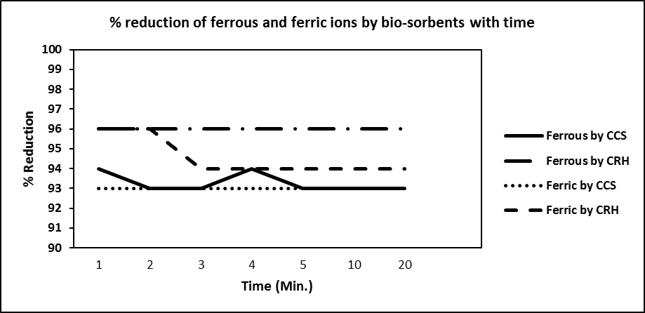
Figure1: Percentage reduction of [Fe²⁺] and [Fe³⁺] by bio-sorbents with varying time at pH 8.5

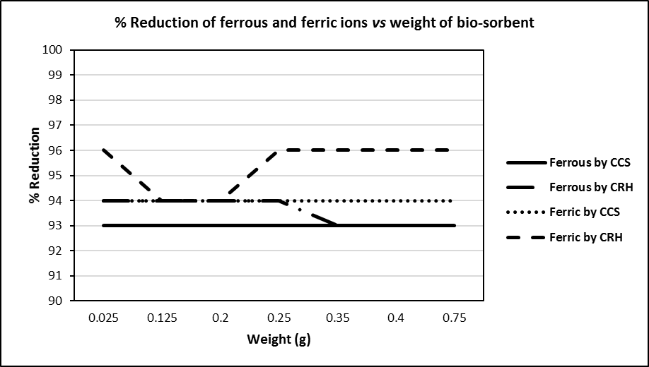

Figure 2: Percentage reduction of [Fe²⁺] and [Fe³⁺] with varying weight of bios-orbents at pH 8.5

Optimum weight and time for both bio-sorbents were 0.025 g (Figure 1) and 1min. (Figure 2) with >93 % reduction for both Fe²⁺ and Fe³⁺. For the further experiments, the optimum weight (0.025 g for 25 mL of water) was considered.

Preliminary investigation on prevention of colour formation
Table 4: Percentage reduction of iron by the bio-sorbents at pH 4
 | Bio-sorbent | Initial concentration (ppm) | Final concentration (ppm) | % of reduction
Fe²⁺ | CCS | 7.0 | 4.5 | 36
 | CRH | 7.0 | 4.9 | 30
Fe³⁺ | CCS | 7.0 | 7.0 | 0
 | CRH | 7.0 | 4.9 | 30

Removal of Fe²⁺ was 36% and 30% by CCS and CRH respectively. Removal of Fe³⁺ was 30% by CRH but 0% by CCS. At pH 4 (Table 4), the % of reduction was decreased by about 60% compared to that at pH 8.5. This may be due to the competition by H⁺ for the adsorption sites at pH 4 and at pH 8.5 precipitation also might have taken place with adsorption simultaneously.

Application of findings to natural tube well water before forming the colour
Table 5: Percentage reduction of total iron by bio-sorbents in natural water
Time of equilibration | Average [Fe]_{initial} (ppm) | With CCS |  | With CRH
 |  | Average [Fe]_{Final} (ppm) | % reduction | Average [Fe]_{Final} (ppm) | % reduction
1 min. | 4.0 | 0.9 | 78 | 0.8 | 80
24 hours | 4.0 | 0.7 | 82 | 0.7 | 82

Both CRH and CCS were effective in removing iron of tube well water (>78%) within 1min. of equilibration (Table 5). It was slightly increased (82%) by both bio-sorbents after 24hours. However, more studies should be carried out to find the mechanism of colour removal to apply the findings to a wider variety of water compositions.

CONCLUSIONS AND SUGGESTIONS
This study was carried out to identify the colour causing substance of water in Chavakachcheri area and to find the possibility to remove or to prevent colour formation using charcoal of rice husk and coconut shell. The following conclusions can be made by the findings of the study carried out.
- Ferrous is oxidized by dissolved oxygen to Ferric.
- Brown colouration is due to the presence of Fe (OH)₃.
- When [Fe³⁺] is less than 2 ppm and [Fe²⁺] is less than 4 ppm no colouration was observed.
- Both charcoals of coconut shell and rice husk (0.025 g for 25 mL of water) can be used as bio-sorbents for removing more than 78% of iron (both Fe²⁺ and Fe³⁺) from water of the area studied.
- Further studies are needed to carry out to apply the findings to different water compositions.

REFERENCES
- American Public Health Association (2005). APHA, AWWA, and WEF Standard methods for the examination of water and waste water. 22nd edn. American Public Health Association, New York, 2005.
- Research committee report on Colour problems (1967). Report for 1966.J.M.Am.Water Works Assoc.59:1023, 1967
- Volesky, B. (1990). Bio-sorption and bio-sorbents. CRC Press, 1990, 3-5.

