SPECTROSCOPIC QUANTIFICATION OF METHANOL IN WINE: METHOD DEVELOPMENT, METHOD VALIDATION AND SAMPLE ANALYSIS

L.A. Wijenayaka¹*, D. Ranasinghe¹, S. Wimalasena²

¹Department of Chemistry, The Open University of Sri Lanka
²Government Analyst's Department, Battaramulla
INTRODUCTION

According to the European standard, the methanol content of wine should be below 450 ppm. Currently, high performance liquid chromatography (HPLC), gas chromatography (GC) and gas chromatograph mass spectrometry (GC-MS) are mostly employed to quantify the methanol in alcoholic beverages. Application of these techniques, however, requires expensive instruments and specialized technical expertise. Hence, their applicability is limited in most laboratories. International Organization for Standardization (ISO) recommended visual colorimetric method (ISO 1388/8-1981(E) for determination of methanol content is applicable between 1,000 - 15,000 ppm. The main goal of the current study, therefore, was to develop a method which can measure less than 1,000 ppm methanol. Hence, the ISO 1388/8- 1981(E) method was modified to allow more sensitive and accurate quantification method for methanol that could efficiently be used for concentrations below 1,000 ppm. Eventually, it was anticipated that the method developed could be used to quantify the methanol content of commercially available foreign wine and ‘homemade’ wine samples.

METHODOLOGY

Apparatus: A UV- visible spectrophotometer (Thermo scientific evolution 201) was used for photometric measurements. An alcolizer (Antor Paar) was used to measure the ethyl alcohol content in wine samples. Gas Chromatography (Shimadzu 2010 plus) with Flame ionization detector was used to measure the methanol levels in wine for method validation.
Reagents and solutions: (1) KMnO₄ (3.000 g) was dissolved in distilled water in 100 ml volumetric flask and orthophosphoric acid (15 ml) was added and was diluted up to the mark with distilled water. (2) Oxalic acid (5.0000 g) was dissolved with 50 % sulfuric acid 100 ml volumetric flask and make to the mark. (3) Schiff reagent: Distilled water (1500 ml) was placed into a 2000 ml volumetric flask and magenta basic powder (4.5000 g) was added and was swirled to dissolve. Thereafter, sodium metabisulfite (9.5000 g) was added and was allowed to stand 10 minutes. Finally, concentrated sulphuric acid (40 ml) was added, the mixture was allowed to stand for 12 hours, and the solution was filtered using activated charcoal. (4) Ethanol solution (10% v/v): methanol free absolute ethanol (50 ml) was added into 500 ml volumetric flask and was diluted to the mark with distilled water.
Original procedure; Methanol standard solution (2000 ppm) was prepared in ethanolic (10 % v/v) medium. The as-prepared standard solution was used to prepare methanol standard series solutions. Ethanolic medium (10% v/v) was used as an internal medium. Each standard of methanol (5 ml) was added into colorimetric tubes and KMnO₄ solution (2 ml) was added into this and allowed to stand for ten minutes. Then, the oxalic acid solution (2 ml) was added. Finally, the Schiff reagent (5 ml) was added and the mixture was allowed to stand for one hour before being used in the analysis. (International Organization for Standardization, 2001)
Modified procedure; methanol standard solution (1000 ppm) was prepared by using distilled water as an internal medium. Stock solution was used to prepare standard series solutions of methanol (1000, 750, 500, 250, 100 ppm). Each methanol standard (1 ml) was added into a colorimetric tube, along with 3.5 ml of ethanol solution (10% v/v) and 2 ml of KMnO₄ solution. This was allowed to stand for 10 minutes and the oxalic acid solution (2 ml) was added in. At the last step, analyte was treated with 5 ml of Schiff reagent, allowed to stand one hour and maximum absorption wavelength (λ_{max}) was measured using UV-visible spectrophotometry. All further spectroscopic measurements were carried out at λ_{max}.

Mechanism; Methanol was oxidized to formaldehyde and further oxidized to formic acid. Formaldehyde to formic acid reaction was controlled by ethanol. Ethanol was oxidized acetaldehyde and further oxidized to acetic acid. These reactions were competitive reactions. Schiff reagent only react with formaldehyde and make Prussian blue colour complex.
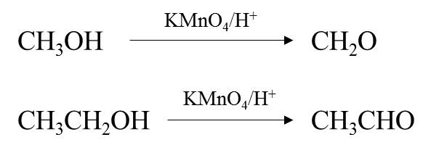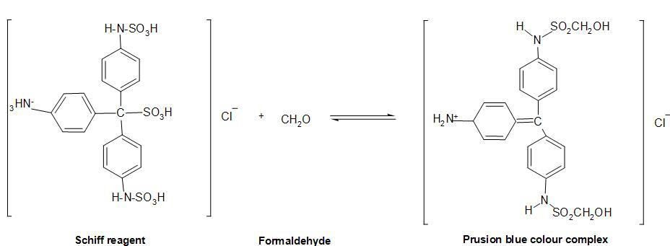

RESULTS AND DISCUSSION

According to the modified procedure, λmax corresponding to the analysis samples was found to be 595 nm. Five methanol standards were used to prepare the calibration plot and all the readings were triplicated. According to the results of all triplicated data sets, the standard deviations (SD) were smaller than ± 1 SD and relative standard deviations (RSD) were less than 5 %. These results suggest the significant accuracy and precision of the modified method. Additionally, it is notable that a good linear relationship was observed in the calibration plot (R2 = 0.9995). The recovery of the modified method was 99.23%. Limit of detection was 29 ppm and limit of quantification was 76 ppm. Linearity range was 76 – 1,000 ppm. Intraday and Interday reproducibility was done for two methanol standards and its RSD values were 0.35 %, 1.35 %. The RSD values were less than 5% of acceptance value. These results which provide merit to the modified quantification method are summarized in figure 1, Tables 1 and 2 below. Overall, the findings confirm that this modified method is more sensitive compared to the ISO standard method.

0.7
0.6
0.5
0.4
0.3
y = 0.0006x + 0.0212
R² = 0.9995
750; 0.506
1000; 0.653
500; 0.344
0.2
250; 0.181
0.1
0
100; 0.081
0 200 400
600
800
1000
1200
Methanol concentration (1,000 ppm)

Absorbance

Figure 1. Calibration curve for methanol

Table 1. Estimated error, relative error and recovery of methanol standards

Standards
(ppm)
Average absorbanc e
Calculated concentration (ppm)

Estimated error
Estimated relative error %

Recovery (%)

100 0.081 94 ±8.025 8.57 93.66

250 0.181 250 ±8.568 3.42 100.96

500 0.344 506 ±10.279 2.03 101.18

750 0.506 759 ±12.622 1.66 101.31

1000 0.653 990 ±15.054 1.52 99.02

Table 2. Precision and reproducibility of standards

Methanol standards (Average results)

Trial 250 ppm 500 ppm
Day 1 0.180 0.344
Day 2 0.181 0.338
Day 3 0.181 0.335
Mean 0.181 0.339
Standard deviation 0.0005 0.0046
RSD % 0.32 1.35
The method developed was validated further by analysis of samples of commercially available red wine (26) and homemade wine (10), and comparison of the results with GC analysis. Most of the red wine samples analyzed contained less than 200 ppm of methanol. Notably, according to the colorimetric and GC results, the modified method produced a close estimation to the value quantified via GC for each foreign wine samples.
Figure 2 shows the comparison results of GC and colorimetric method obtained for the homemade wine samples. Although the colorimetric method provides a close estimation to the GC measured value in most cases, these results highlight that the variation between colorimetric and GC measured concentrations become more apparent at lower methanol concentrations. Hence, the adoptability of the modified approach in detecting significantly lower levels of methanol is questionable. However, it is notable that at levels of methanol around or above the permissible levels, the modified method indicates acceptable accuracy. Hence, the development of a simple visual qualitative test for detecting methanol above its permissible levels is likely, based on the experimental understanding obtained here.

Figure 2. Comparison of GC (blue) and modified colorimetric (orange) results for measurements made on homemade wine samples
30
26.865 26.812
25
19.370
20.082
20
16.116
15
11.945
13.541
10
9.300
9.256
7.473
5

0
APPLE
GRAPES
MADAN
Homemade wine sample
NELLI
STAR FRUITS
GC Colorimetric
Concentration (ppm)

CONCLUSIONS

A modified colorimetric method for the detection of methanol was developed based on the existing ISO standard method. Further validation of the developed method indicated it to demonstrate properties that would add merit to its analytical ability. When applied for the analysis of real samples, it was apparent that the modified approach results a close estimation to the GC measured methanol levels, specifically at higher concentrations of methanol. However, when the methanol levels are significantly lower than the permissible values, specifically at the levels present in the homemade wines, deviations are apparent between the two approaches. Nevertheless, based on the findings of this study, the modifications are capable of improving the sensitivity of the standard colorimetric method that allows efficient methanol detection, specifically at or above levels permissible in alcoholic beverages. Hence, the overall findings suggest the possibility of utilizing the modifications adopted here as to develop a simple and efficient qualitative colorimetric tool for testing the compliance of alcoholic beverages to standard permissible levels of methanol, as potential future direction.

REFERENCES

International Organization for Standardization. (2001). Ethanol for industrial use - Methods of test - Part 8: Determination of methanol content (methanol contents between 0,10 and 1,50 % (V/V)) - Visual colorimetric method (ISO Standard No. 1388/8-1981(E)). https:// www.iso.org/standard/5950.html

ACKNOWLEDGMENTS

Authors would like to extend their gratitude toward the Government Analyst’s Department for providing the facilities to conduct this research.

