THE EFFECT OF GREEN SYNTHESIZED SILVER NANOPARTICLES ON INTACT WASTEWATER AND SELECTED PATHOGENIC BACTERIA

S. A. Kumar¹*, K. Vivehananthan²
¹Department of Biotechnology, Wayamba University of Sri Lanka
²Department of Basic Sciences, The Open University of Sri Lanka

INTRODUCTION
As a result of increasing world population, environmental pollution increases in an alarming rate. Thus, one of the most pressing health crises in the world is water pollution. The both human and environmental health will adversely be affected if wastewater is not managed properly. Synthesis of nanoparticles using plants has proven advantageous over other biological processes as they are easily available and safe to handle. Azadirachta indica leaf extract is effectively involved in green synthesis of silver nanoparticles due to its feasible nano-transformation process (Verma and Meheta, 2016).

It is an overt fact that silver nanoparticles are highly toxic to microorganisms and endow bactericidal and fungicidal effect (Wang et al., 2016). Previous studies have shown that silver nanoparticles could be successfully utilized against multi drug resistant pathogens such as Salmonella typhi and Staphylococcus aureus (Saravanan et al., 2018). Since water pollution is a major global problem and also it is the leading worldwide cause of deaths and diseases, silver nanoparticles could be utilized effectively for remedial purposes because of their tremendous antimicrobial activity. The present study focuses on green synthesis and it investigates the potential antibacterial activity of silver nanoparticles on household and farm yard wastewater and selected bacterial species such as Staphylococcus aureus and Escherichia coli.

METHODOLOGY

Green Synthesis and UV Characterization of Silver Nanoparticles
AgNPs were green synthesized by mixing 2.5 g/100 mL neem leaf extract with 0.001 M silver nitrate. Then the synthesized AgNPs were initially characterized by color change and further by UV-Visible spectroscopy (model U-1800). Afterwards, AgNPs were pelleted down by centrifugation at 12 000 rpm for 15 min. The different concentrated AgNPs solutions such as 20 µg/mL, 25 µg/mL, 30 µg/mL, 40 µg/mL and 50 µg/mL were prepared to evaluate the antibacterial activity of the green synthesized nanoparticles on intact wastewater samples as well as selected pathogenic bacteria.

Sample Collection and Evaluation of Antibacterial Activity of Green AgNPs

The household and farm yard wastewater samples were collected from Ratmalana, Colombo. Three replicates (1 L volume each) of samples were collected and those were transported to the laboratory at room temperature.

Each prepared AgNPs solution was mixed with farm yard and household wastewater samples at 1:40, 1:80 and 1:120 ratios. Then, those were shaken for 3 h at 120 rpm using modified wastewater treatment protocol (Sheng et al., 2015). Wastewater without nanoparticle was also used as the control sample. Bactericidal effect was studied by plating 20 µL aliquot from each mixture as well as control sample and cultured in nutrient agar medium at 37 °C incubation for an overnight. As a preliminary screening, overall effectiveness in controlling bacterial growth was tested on intact wastewater samples with the green silver nanoparticles. Simultaneously, the efficacy of silver nanoparticles was investigated against two bacteria species such as Staphylococcus aureus, as a gram-positive pathogenic bacterium (Bassetti et al., 2009) and Escherichia coli, as a gram-negative bacterium (An et al., 2007) as these are commonly found in wastewater. Therefore, in the present study as a primary step, the initial screening was performed on the selected pathogenic bacteria only. As the control experiment, same procedure was followed without treating those two bacterial species with silver nanoparticles. After the exposure to the silver nanoparticles, the viable bacterial population of the tested samples were determined through a comparison between control plates and treated plates in all the set up.

`RESULTS AND DISCUSSION

Green Synthesis of AgNPs and UV Characterization

The green synthesis is an easy, economical and eco-friendly way to synthesize silver nanoparticles while green synthesized silver nanoparticles show a better control over their characteristics, size and shape (Nazeruddin et al., 2014). In the present study, formation of green synthesized AgNPs was initially confirmed by color change from pale yellow to ruby red color. Further, the UV-Visible spectrum of the synthesized silver nanoparticles by neem leaf extract showed strong absorption peak ranging (429-435) nm indicating the formation of AgNPs in the solution.

Antibacterial Activity of Green AgNPs on intact Wastewater Samples
Further, the green synthesized nanoparticles were applied to control the bacterial growth in different wastewater samples such as house hold wastewater and farm yard wastewater. The results revealed that the application of green silver particles were found to be effective in reducing the bacterial population in treated plates. However bacterial population was significantly reduced in the concentration range of (25-50) µg/mL of AgNPs solution with 1:40 corresponding ratio which exhibited the effectiveness of AgNPs against bacteria in both household and farm yard wastewater (Figure 1). Further, it was also noted in repeated experiments that the possible countable bacterial colonies were not observed in control plates. Apart from that, bacterial lawns were obtained in control plates due to the high microbial population density in the collected wastewater samples as revealed in Figure 1 (a) & (c). Therefore, the results were interpreted as there was a considerable bacterial population reduction in treated plates with green silver nanoparticles as 95% bacterial population reduction was observed in household wastewater sample (Figure 1b) and 80% reduction of bacterial population in farm yard wastewater sample (Figure 1d) used for the present study.
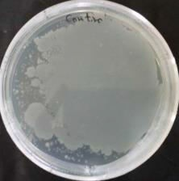
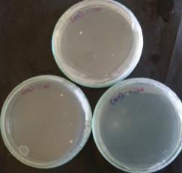
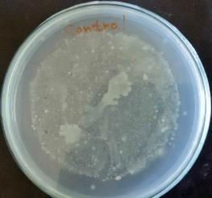
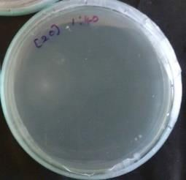
a
b
c
d

Figure 1. Microbial plating results from the concentration range of (25-50) µg/mL of AgNPs at 1:40 ratio. The farm yard wastewater sample before the treatment (a), after the treatment (b) and the household wastewater sample before the treatment (c), after the treatment (d).
Application of Green AgNPs to inhibit the growth of Pathogenic Bacteria
It is a well-known fact that Staphylococcus aureus is a pathogenic bacterium associated in a huge spectrum of human infections including skin infections and pneumonia (Bassetti et al., 2009). Besides, Escherichia coli risk assessment is marked important in wastewater reuse in agricultural fields (An et al., 2007). As these two bacterial species are involved in human infections and reclaimed wastewater, it will be massively important to suppress these bacterial populations by using silver nanoparticles as a novel and intact technique.
The bactericidal effect of silver nanoparticles tested against specific bacterial cultures Staphylococcus aureus and Escherichia coli are shown in figure 2. Across all treatment plates, a considerable reduction of bacterial population was detected in both bacterial species and the most effective AgNPs concentration was found as 25 µg/mL. According to previous studies, nanoparticles have demonstrated antimicrobial activity against different pathogenic microorganisms which indicates the possibility of silver nanoparticles to be used in wastewater management in an effective way (Wang et al., 2016).

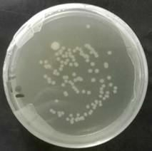
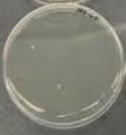
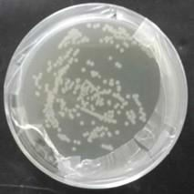
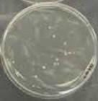
a
b
c
d

Figure 2. Microbial plating results at 10-15 dilution for Staphylococcus aureus and Escherichia coli. Staphylococcus aureus before the treatment (a), after the treatment with 25 µg/mL AgNPs solution (b) and Escherichia coli before the treatment (c), after the treatment with 25 µg/mL AgNPs solution (d).

CONCLUSIONS
The present study concludes that AgNPs are found to be the most effective in reducing bacterial population in wastewater as 95% reduction is observed in household wastewater sample while 80% reduction of bacterial population in farm yard wastewater sample. Furthermore, application of AgNPs inhibits the growth of selected bacteria Staphylococcus aureus and Escherichia coli used in the present study.

REFERENCES

An, Y. J., Yoon, C. G., Jung, K. W & Ham, J. H. (2007). Estimating the microbial risk of E. coli in reclaimed wastewater irrigation on paddy field. Environmental Monitoring and Assessment, 129 (1-3), 53-60.
Bassetti, M., Nicco, M & Mikulska, M. (2009). Why is community-associated MRSA spreading across the world and how will it change clinical practice? International Journal of Antimicrobial, 34, S15-S19.
Nazeruddin, G. M., Prasad, N. R., Waghmare, S. R., Garadkar, K. M & Mulla, I. S. (2014). Extracellular biosynthesis of silver nanoparticle using Azadirachta indica leaf extract and its anti-microbial activity. Journal of Alloys and Compounds, 583, 272-277.
Saravanan, M., Barik, S. K., Mubarak Ali, D., Prakash, P & Pugazhendhi, A. (2018). Synthesis of silver nanoparticles from Bacillus brevis (NCIM 2533) and their antibacterial activity against pathogenic bacteria. Microbial Pathogenesis, 116, 221-226.
Sheng, Z., Van Nostrand, J. D., Zhou, J & Liu, Y. (2015). The effects of silver nanoparticles on intact wastewater biofilms. Frontiers in Microbiology, 6:680.

Verma, A & Mehata, M. S. (2016). Controllable synthesis of silver nanoparticles using Neem leaves and their antimicrobial activity. Journal of Radiation Research and Applied Sciences, 9(1), 109-115.
Wang, W., Kim, Y. J., Singh, P., Mathiyalagan, R., Jin, Y & Yang, D. C. (2016). Green synthesis of silver nanoparticles by Bacillus methylotrophicus, and their antimicrobial activity. Artificial cells, Nanomedicine, and Biotechnlogy, 44(4), 1127-1132.

