FEASIBILITY OF USING EXPANDED POLYSTYRENE BEADS TO PRODUCE LIGHTWEIGHT CEMENT BLOCKS

D.C.H. Chandrasena, K.G .J.K. Kurundumulage, M.M.F. Ahamed,
L. S. S Wijewardena*

Department of Civil Engineering, The Open University of Sri Lanka

INTRODUCTION
In the field of building construction in Sri Lanka, cement blocks is the most commonly used element. Cement blocks are mainly used for the construction of external and internal walls of buildings and boundary walls. There are two types of cement blocks: load-bearing blocks where the structural loads are carried by the block in addition to its own weight, and non-load bearing blocks where only the self-weight of the block is carried on its own.

Now in Sri Lanka, there is a trend of constructing tall buildings for mixed developments. They are framed structures and the walls within these frames are non-load bearing and serve only as partitions. Current practice is to use conventional cement blocks made out of cement-sand mortar mix and the weight of these walls is a substantial percentage in comparison to the weight of the framed structure. If this cement blocks can be replaced with a relatively lighter block, substantial savings can be made by the reduction of the sizes of the structural members, especially the beams, columns, and the foundation.

Different kinds of lightweight materials such as pumice, sawdust, sintered fly ash, expanded shale, Autoclaved Aerated Concrete (AAC), and expanded polystyrene (EPS) beads are used to produce lightweight blocks. An attempt was made in this study to produce lightweight cement blocks using EPS beads. EPS is a product which is commercially available, with its in-built lightweight, good energy-absorbing characteristics, and good thermal insulation (Foamex innovative polystyrene, 2019). Moreover, if the EPS used in packaging materials, which is not biodegradable, can be used in a sustainable manner, it will not end in landfills causing environmental hazards and pollution.

Sri Lanka Standards Institution has published standards applicable to requirements and test methods applicable to cement blocks (SLS 855: Parts 1 – 2, 1989). SLS 855 stipulates the requirements to be satisfied by non-loadbearing blocks.

METHODOLOGY

A standard block size of 390mm x 190mm x 100mm was selected conforming to SLS 855 Part 1. Steel moulds of precise inner dimensions were used for the preparation of the test specimen.

Ordinary Portland Cement (OPC) was used in the preparation of the specimens and M-sand sieved through 4.76mm was used as the fine aggregate. EPS beads of size 3-5 mm diameter were used to make the specimens. A smaller size range was selected since past studies concluded that the smaller particle size of EPS beads results in higher strengths (Juan Bosco et. al., 2013).

A cement: sand ratio of 1:2 was selected as mortar based on initial trials conducted to determine the mix proportions to achieve the required strength and bonding properties. During the preparation of the mortar mix, after mixing cement and M-sand, the mixture was

moisturized before adding EPS beads, to avoid the floating of EPS beads (Gamage & Tharmarajah, 2018). A water:cement ratio of 0:35 was selected based on a past study (Sayanthan et.al., 2013) to obtain the desired properties.

The mortar mix was replaced with 20%, 30%, 35%, 40% & 50% of EPS beads in preparing the test specimens. A control mix was prepared without adding EPS to compare the block properties with conventional cement blocks.

The cement blocks were cast using steel moulds prepared by using hand tamping as the compaction method. The prepared blocks were kept in the mould for one day and were then demoulded. AS shown in Figure 1, the blocks were kept inside the laboratory for curing until testing.

Compressive strength, water absorption, moisture content and wet/dry density tests were done as recommended in SLS 855: Part 2 (1989) to determine the optimum mix proportion in making the lightweight cement block.

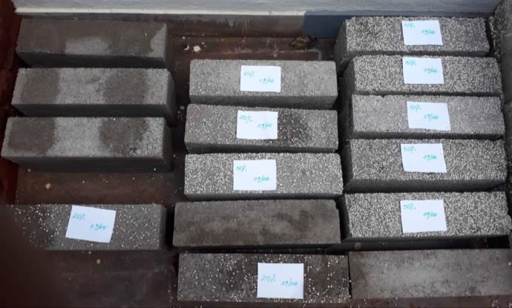

Figure 1: Prepared blocks kept for curing

RESULTS AND DISCUSSION

Compressive Strength

SLS 855: Part 1 (1989), specifies that the minimum strength of a lightweight, non- loadbearing cement block should be 1.2 N/mm2. However, it does not specify the curing period. Hence, compressive strength was tested after 14 and 28-day curing periods and the results are shown in Figure 2.

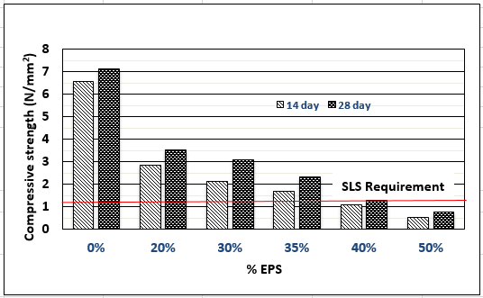
Figure 2: Compressive strength results

After 14 days of curing, all the cement blocks except for those cast with 40% and 50% of EPS, have exceeded the required compressive strength of 1.2 N/mm2 as specified by the SLS 855: Part 1 (1989). After 28 days of curing all the cement blocks except for those cast with 50% of EPS have achieved the required crushing strength of 1.2 N/mm2. Assuming that the building loads are applied after 28 days of casting, which is a reasonable assumption, 40% replacement with EPS is possible.

Water absorption

SLS 855: Part 1 (1989) only specifies the test method but does not specify a required water absorption percentage for cement blocks. Upper limit of water absorption recommended for Compressed Stabilized Earth Blocks (CSEB) given in Table 3 of SLS 1382: Part 1 (2009) is 15%. Water absorption of all test specimens in this study is within 10% - 12% and hence, it can be concluded that water absorption is acceptable for cement blocks.

Moisture content

SLS 855: Part 1 (1989) specifies an acceptable moisture content for cement blocks as 40%. The blocks prepared with all the mixes including the control mix have achieved moisture contents less than 40% satisfying the SLS requirement as shown in Figure 3.

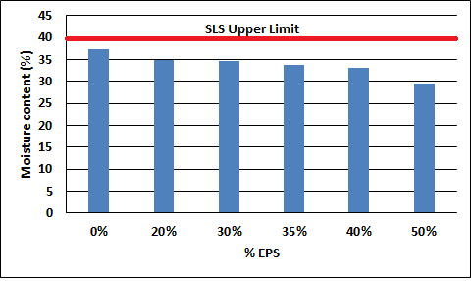

Wet/dry density
Figure 3: Moisture content results

Figure 4 (a) shows the wet and dry densities obtained for tested samples and the percentage reduction in density when compared with the density of the blocks made without adding EPS is plotted in Figure 4 (b). Based on these results, it can be concluded that the percentage reduction in density is nearly equal to the percentage of EPS added.

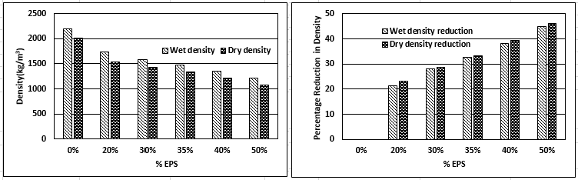

      - Wet/dry density; (b) Percentage reduction in wet/dry density Figure 4: Results of density

CONCLUSIONS/RECOMMENDATIONS

Considering the aspects of achieving the required crushing strength within 14 days, better visual appearance and uniform distribution of EPS beads in the cement block 35% volumetric replacement of mortar with EPS beads can be concluded as the optimum mix proportion. It achieves a 33% weight reduction while satisfying all the criteria specified in SLS 855 for non-loadbearing cement blocks.

A separate cost analysis carried out indicated that the material cost of a cement block with 35% EPS beads (Rs 111.53) is slightly higher than that of a block made with control mix of 1:2 cement mortar (Rs. 106.91). Purchasing EPS in bulk will reduce the cost of the cement blocks drastically eliminating that problem.

Therefore, it can be concluded that lightweight cement blocks made by mixing 35% EPS beads volumetrically results in a dead load reduction of one third transferred to the structure which in turn would result in a substantial saving on the cost of structure.

No durability tests were conducted in this study, but due to the very long lifetime of EPS any serious problems associated with durability is expected with blocks made with EPS considering the lifetime of buildings. However, it is important to state that the fire resistance of the blocks need to be studied as EPS is vulnerable when exposed to high temperatures.

REFERENCES

Specification for Cement Blocks - Sri Lanka Standard 855 (1989), Part 1: Requirements, Part 2: Test Methods, Sri Lanka Standards Institution

Specification for Compressed Stabilized Earth Blocks - Sri Lanka Standard 1382 (2009), Part 1: Requirements, Sri Lanka Standards Institution

Gamage, D.N., Tharmarajah, G, (2018). Lightweight non-load bearing blocks using expanded polystyrene beads. Faculty of Engineering, Institute of Information Technology, Sri Lanka.

Sayanthan, R., Ilamaran, S., Rifdy, M. & Nanayakkara, S.M.A (2013), Development of interlocking lightweight cement blocks. Department of Civil Engineering, University of Moratuwa, Sri Lanka.

Juan Bosco, Hernández-Zaragoza, Teresa López-Lara & Jaime Horta-Rangel (2013), Cellular Concrete Bricks with Recycled Expanded Polystyrene Aggregate. Faculty of Engineering, Autonomous University of Queretaro.

Foamex innovative polystyrene (2019) What Is Expanded Polystyrene. Retrieved from: https://www.foamex.com.au/technical/what-is-expanded-polystyrene

ACKNOWLEDGMENTS
Authors acknowledge the support extended by the chief engineer, research officer and all other staff members and laborers of Kaluthara project of Road Development Authority by permitting to use their laboratory facilities at Bandaragama site office and by assisting in carrying out most of the laboratory testing.

