ANTI-HYPERCHOLESTEROLEMIC ACTIVITY IN PLANT SPECIES OF THE FAMILY EUPHORBIACEAE ON CHOLESTEROL-INDUCED WISTAR ALBINO RATS
D.M.L.C. Dissanayaka¹, N. Nilakarawasam^{2*}, S.R. Weerakoon¹, S. Somaratne¹, C. Ranasinghe³
¹Department of Botany, The Open University of Sri Lanka
²Department of Zoology, The Open University of Sri Lanka
³ Department of Chemistry, The Open University of Sri Lanka

Introduction
The increased serum cholesterol level is known as hypercholesterolemia: a condition which leads to development of atherosclerosis and coronary heart diseases (Yadav et al., 2014). In the recent years, there is growing interest in search of anti-hypercholesterolemic plant metabolites (Maruthappan and Sakthi, 2010). Traditional medicinal plants having anti-hypercholesterolemic property can prove to be a useful source for the development of new oral anti-hypercholesterolemic agents or simple dietary adjuvant to existing therapies. Ethnopharmacological surveys indicate that more than 1200 plants are used in traditional medicine for their anti-hypercholesterolemic activity (Grover et al., 2002, Li et al., 2004). The anti-hypercholesterolemic activity of several plants/plant products has been evaluated and confirmed in animal models (Gupta et al., 2005, Kesari et al., 2006) as well as in humans (Herrera-Arellano et al., 2004, Jayawardena et al., 2005). The plants of the family Euphorbiaceae possess various medicinal properties (Asha et al., 2006; Maruthappan and Sakthi, 2010, Chauhan et al., 2010). The variations in the medicinal properties of Euphorbiaceous species are possibly due to stress factors of the habitat of the species. These stress factors seemingly operated in association with genetic factors such as gene expression and mutation leading to bring about the synthesis of a wide assemblage of secondary substances, are of medicinal importance. The ecological distribution and the presence of a wide range of unusual secondary metabolites made most of the family members poisonous (Seigler, 1994). The family Euphorbiaceae is well represented in Sri Lanka with considerable endemicity and distribution in diverse ecological habitat and most of these species are not subjected to anti-hypercholesterolemic screenings. Hence, the present study was aimed to investigate anti-hypercholesterolemic activity of nine (09) plant species of family Euphorbeaceae i.e. Phyllanthus amaderaspatensis L., P. reticulatus Poir. (‘Welkayla’), P. polyphyllus Willd. (‘Kuratiya’), P. amarus Schum. (‘Pitawakka’), Glochidion zeyalanicum (Gaertn.) A.Juss. (‘Hunukirilla’), G. montanum Thw., Bridelia retusa (L.) A. Juss. (‘Katakela’), B. mooni Thw. (‘Patkela’) and Emblica offiscinali (‘Beheth nelli’) on hypercholesterolemia induced Wistar albino rats.

Material and Methods
Plant collection and extraction
The fresh whole plants were collected from various regions in Sri Lanka. Collected plant parts, barks/fruitsleaves were dried in shade for three weeks. Dried plant parts were powdered mechanically, and samples were subjected to Soxhlet extraction with methanol at 64°C for 6-8 hr. Extracts were evaporated at 40°C using a rotary evaporator. Evaporated samples were dried in vacuum oven until constant weight was gained.
Experimental animal/s
Healthy adult male Wistar albino rats (Mus norvegicus albinus) weighing between 180-200 g were purchased from Medical Research Institute, Borella, Sri Lanka. They were kept under standardized animal house conditions (Photoperiod: approximately 12 h natural light per day, temperature: 28-30°C, humidity: 55%-60%) with water and standard diet ad libitum. The experimental animals were acclimatized for 7 days before the commencement of the study. Ethical clearance for the study was obtained from the Ethical (IOB ethical clearance reference number ERC IOBSL 121 04 15) review committee of the Institute of Biology, Sri Lanka.
Experimental design
First, the acute toxicity of the crude methanolic extracts of P. maderaspatensis L. (CMEPM), P. reticulatus Poir. (CMEPR), P. polyphyllus Willd. (CMEPP), P. amarus Schum. (CMEPA), G. zeyalanicum (Gaertn.) A.Juss. (CMEGZ), G. montanum Thw. (CMEGM), B. retusa (L.) A. Juss. (CMEBR), B. mooni Thw. (CMEBM) and E. offiscinalis (CMEEO) at the dosage of 2000mg/kg body weight was evaluated according to standard guidelines (OECD/OCDE No: 423) at the end of 14th day. Acute toxicity signs were observed (Ogbonnia, 2003) and at the same time whether the extract has any effect in lowering cholesterol level in blood was investigated (Rajasekaran et al., 2013).
Rats were divided into groups (n = 06/group) of six animals each. Hypercholesterolemia was induced in rats by force feeding a mixture of egg yolk (20 ml), butter (50 g) and cow ghee (20 ml). Equal amounts of the mixture (~2 ml) were given to all the rats except the negative control group (NCG) once a day orally throughout the experiment. The amount of 2000mg of dried crude methanolic extracts of P. maderaspatensis L. (CMEPM), P. reticulatus Poir. (CMEPR), P. polyphyllus Willd. (CMEPP), P. amarus Schum. (CMEPA), G. zeyalanicum (Gaertn.) A.Juss. (CMEGZ), G. montanum Thw. (CMEGM), B. retusa (L.) A. Juss. (CMEBR), B. mooni Thw. (CMEBM) and E. offiscinalis (CMEEO) were dissolved in 2mL of water and were introduced to rats in each group. Rats in the NCG and positive control group (PCG) were given distilled water as the vehicle.
Evaluation of blood parameters
Blood samples (2ml) were collected from anesthetized rat’s tail vein with the assistance of a rat holder. Collected blood samples were centrifuged within one hour at 3500 rpm for 30 minutes to obtain serum. Total cholesterol (TC), Triglyceride (TG), HDL Cholesterol (HDL-C) were measured using standard kits (Biolabo reagents-Maizy, France) and LDL Cholesterol (LDL-C) was calculated using the following formula. Blood parameters were evaluated at the beginning, 7th and 14th days of the experiment.
TG
LDL-C = TC - HDL-C (mg/dl)
5

Statistical analysis
Descriptive statistics such as mean and standard deviation were calculated. The deviations between the PCG and treated groups were subjected to one-way analysis of variance (ANOVA) and multiple comparison test (Tukey HSD) using SPSS Ver. 20. The acceptable level of significance was p < 0.05.
Results and Discussion
In the rats treated with acute dose 2000mg/ kg, no acute toxic signs such as salivation, sleep, diarrhea, and tremors, lethargy or mortality were observed up to 14 days. However, within two weeks in the post experimental period five rats in the sample treated with CMEBR were dead indicating its possible toxic effects.
The results indicated that there is a significant (p ≤0.05) decrease in total cholesterol in rats treated with CMEPM, CMEPA, CMEEO and CMEBR on 7th day of the experiment. In addition, rats treated with CMEPR and CMEGZ showed a significant decrease of total cholesterol by 14th day of the experiment. CMEPP, CMEGM and CMEBM were unable to reduce total cholesterol significantly (p ≤0.05) in rats even by the end of the experiment (Figure 1a).
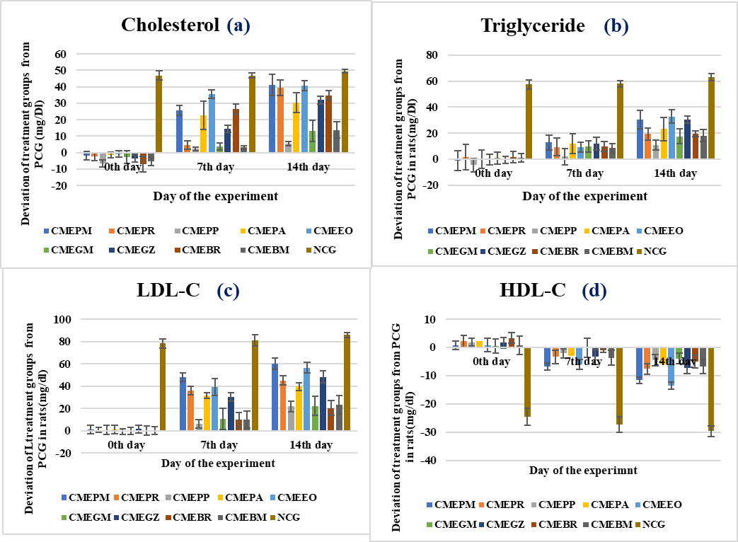
Figure 1. Deviation of total cholesterol (a), triglyceride (b), LDL-C (c) and HDL-C (d) from PCG in rats
PCG- Positive Control Group
Although there was a decrease of triglyceride levels by all the extracts, there was no significant difference among them by the 7th day of the treatment. However, by the 14th day CMEPM, CMEEO and CMEGZ were able to decrease triglyceride in rats significantly (p≤0.05) compared to other plant extracts (Figure 1b).
These plant extracts have been able to decrease LDL-C and increase HDL-C levels in blood serum. The results obtained for LDL-C levels in rats, showed a significant (p ≤0.05) reduction by the extracts of CMEPM, CMEPR, CMEPA, CMEEO and CMEGZ on both 7th and 14th days of the experiment while other extracts failed even at the end of the experiment (Figure 1c).
The rats treated with CMEPM and CMEEO indicated significant (p≤0.05) increments in HDL-C on 7th day of the experiment. By the end of the experiment, CMEPR, CMEPA, CMEGZ and CMEBM extracts increased HDL-C significantly (p≤0.05) in rats (Figure 1d).
Flavonoids have been reported to increase HDL-C levels and decrease LDL and VLDL levels in hypercholesterolemic rats (Miller et al., 2017). The presence of flavonoids and polyphenols in most active plant extracts could be considered as attributive compounds in increasing HDL and decreasing LDL in extracts-treated rats.
Conclusions
Results of the present study reveal that the crude methanolic extract of P. maderaspatensis and E. officinalis has the highest anti-hypercholesterolemic activity among tested Euphorbiaceous plants. Further studies are required to understand the possible mechanism/s of action.
Acknowledgements
The authors would like to acknowledge the financial support provided by OUSL Competitive Research Grant-2014 (OU201401).
References
Asha, V.V., Sheeba, M.S., Suresh, V. and Wills P.J. (2007). Hepatoprotection of Phyllanthus maderaspatensis against experimentally induced liver injury in rats. Fitoterapia, 78,134-141.
Chauhan, A., Sharma, P.K., Srivastava, P., Kumar, N. and Dudhe, R. (2010). Plants having potential antidiabetic activity: A Review. Der Pharmacia Lettre 2: 369-387.
Grover, J.K, Yadav, S, Vats, V. (2002). Medicinal plants of India with anti-diabetic potential. J Ethnopharmacol, 81, 81–100.
Gupta, R.K, Kesari. A.N, Watal, G, Murthy, P.S, Chandra, R, Tandon, V. (2005). Nutritional and Hypoglycemic Effect of Fruit pulp of Annona squamosa in Normal Healthy and Alloxan-Induced Diabetic Rabbits. Annals Nutri Meta, 49,407–13.
Herrera-Arellano, A, Aguilar-Santamaria, L, Garcia-Hernandez, B, Nicasio-Torres, P, Tortoriello J. (2004). Clinical trial of Cecropia obtusifolia and Marrubium vulgare leaf extracts on blood glucose and serum lipids in type 2 diabetics. Phytomedicine, 11,561–566.
Jayawardena, M.H, De Alwis, N.M, Hettigoda, V, Fernando, D.J. (2005). A double-blind randomized placebo controlled cross over study of herbal preparation containing Salacia reticulata in the treatment of type 2 diabetes. J Ethnopharmacol, 97,215–218.
Kesari, A.N, Gupta, R.K, Singh, S.K, Diwakar, S, Watal, G. (2006). Hypogycemic and antihyperglycemic activity of Aegle marmelos Seed Extract in Normal and Diabetic Rats. J Ethnopharmacol, 107,374–379.
Li, W.L, Zheng, H.C, Bukuru, J, De Kimpe, N. (2004). Natural medicines used in the traditional Chinese medical system for therapy of diabetes mellitus. J Ethnopharmacol, 92, 1–21
Maruthappan, V. and Sakthi, S.K. (2010). Effects of Phyllanthus reticulatus on lipid profile and oxidative stress in hypercholesterolemic albino rats. Indian Journal of Pharmacology, 42, 388-391.
Millar, C.L., Duclos, Q., Blesso, C.N. (2017). Effects of Dietary Flavonoids on Reverse Cholesterol Transport, HDL Metabolism, and HDL Function. Advances in Nutrition, 8(2), 226–239.
Ogbonnia, S.O., Adekunle, A., Olagbende-Dada1, S.O., Anyika, E.N., Enwuru, V.N. and Orolepe, M. (2008). Assessing plasma glucose and lipid levels, body weight and acute toxicity following oral administration of an aqueous ethanolic extract of Parinari curatellifolia Planch, (Chrysobalanaceae) seeds in alloxan-induced diabetes in rats. African Journal of Biotechnology, 7, 2998-3003.
Rajasekaran, A., Sivakumar, V. and Darlinquine, S. (2013). Effect of Blepharis maderaspatensis L. Roth. Extracts on serum lipids in Triton WR-1339 and high cholesterol diet induced hyperlipidemia in rats. African Journal of Pharmacology 7: 2577-83.
Seigler, D.S., (1994). Phytochemistry and systematics of the Euphorbiaceae. Annals of the Missouri Botanical Garden. 81(2) No. 2: 380-401.
Yadav, V., Upadhyay, V., Dinesh Deepak Ravinder. (2014). Importance of herbs in the treatment of hyperlipidaemia. Scholars Academic Journal of Pharmacy, 3(3), 306-312.

