THE CORRELATION OF DEMOGRAPHIC FACTORS WITH THE SKILL LEVEL OF MEDITATORS: A PILOT STUDY

H.M.N.N. Dasanayaka^{1*}, E.A.S.K. Somarathne1, N.O. Outschoorn 1, K.K.Vithanage2, K.P.C. Dalpatadu 2, M.W. Gunathunga 3, H.M.J.C. Herath4, K.S.A. Jayasinghe5, W.D.N. Dissanayake 1, 2

¹Research Promotion and Facilitation Centre, University of Colombo
²Department of Physiology, University of Colombo.
³ Department of Community Medicine, University of Colombo.
⁴ Department of Social Science Education, University of Colombo.
⁵Department of Clinical Medicine, University of Colombo.

Introduction
Meditation requires rigorous spiritual and psychophysical training and can result in a range of benefits such: creating a clear, stable, and calm mind; increasing focus; self- awareness; relaxation; and tranquillity. (Cahn & Polich, 2006). Meditation is one of the safest practices in Complementary and Alternative Medicine (CAM) (Sinn, Sharma, & Datta, 1997), and it plays a vital role in addressing the issue increasing illness rates in the modern world (Ramaswami & Shiek, 1989). About three billion people (i.e. 65%-80%) of the world population practices, CAM for the treatment of various diseases and to maintain good health (Goldstein, 1999). Attention to breathing, loving kindness and compassion are the more commonly known meditation techniques that are used to heal mental illnesses (Levine et al., 2017). However, according to the Buddhist teachings, meditation enables the attainment of “Niramisa Suwa” by helping the removal of suffering (Amihai & Kozhevnikov, 2014; Deegalle, 2017).
Yates (2017) in his work on meditation has coined the term “skilled meditators” by formulating parameters to recognize the level of a meditator. This though is not a declaration made by the Buddha, as he presented only one goal, which was to end suffering using meditation as a technique to calm down and analyze the mind. Those who end suffering thus, do not go through a time frame to attain certain levels per say. Yet, the modern world has found the benefits of meditation in day to day life thus, Yates has stated that there are ten stages and four milestones in becoming a skilled meditator. Accordingly, a skilled meditator is an individual who has passed stage one, two and three and has established a practice where they are able to sustain uninterrupted attention, overcoming mind-wandering, possess extended attention and has overcome forgetfulness. They are considered to be in stages four to six where a meditator achieves continuous attention, has overcome gross distraction and strong dullness, has overcome subtle dullness, has increased mindfulness and has subdued subtle distraction (Yates, 2017). Research on meditation, which leads to becoming a skilled meditator can add new knowledge to the growing body of literature. Research on this topic can be used to improve the quality of life of people physically, genetically and psychologically. Scientific research has shown that the effects of meditation can have beneficial effects on genetics via reducing the shortening of telomere length (Hoge. et al., 2013; Alda, et al., 2016; Le et al., 2019; Puhlmann, et al., 2019; Mendioroz, et al., 2020), increasing the activity of telomerase (Jacobs, et al., 2010; Tolahunase, 2018), and up-regulating or down-regulating the gene expressions (Cresswell, et al., 2013; Kaliman, et al., 2015; Duraimini, et al., 2015). Previous studies have also evidenced that meditation can have beneficial effects on immunology and other physiological parameters through reducing pro-inflammatory process, increasing cell mediated defense parameters, increasing the activities of enzymes (van Genderen, et al., 2011; Bower, et al., 2015; Malarkey, et al., 2014), increasing the intensity of slow alpha activity (8-9 Hz) in central and frontal regions, decreasing beta (12-14 Hz) and delta (2-4 Hz) waves (Wallace, et al., 1982), and reducing systolic and diastolic blood pressure (Benson, et al., 1974; Cooper, & Aygen, 1978). In addition, meditation may cause beneficial effects of the psychological parameters by decreasing stress, anxiety, and depression (Conklin, et al., 2018; Pipe, Bortz, & Cn, 2009; Dada, Kumar, Bisht, & Khan, 2016). Thus, the aim of this study was to seek the correlation between skill level of a meditator against eight factors, which include age, gender, body mass index (BMI), sleeping hours per day, diet type, highest educational achievement, duration of the meditation experience, and frequency of meditation per day (minutes per day).

Methodology

The participants of this study included twenty meditators who were aged over 18 years and were residing in the Western Province. Pregnant and breastfeeding mothers, smokers and those who identified as having psychiatric disorders were excluded from the study. A questionnaire titled ‘intake interview’ was used to check the skill level of the meditators. It was validated through the following steps: review of literature, pre- condition, test development, confirmation (empirical analyses), administration, score scales and interpretation, and documentation. This “intake interview” consists of 30 questions that examine six areas including the duration of meditation practice, details of meditation practice, heightened peripheral awareness, stable attention, alertness and emotional stability. The questionnaire was administered to meditators to access their skill level. The findings were individually scored to calculate a single score that reflected the skill level of the meditator. Furthermore, the eight factors that include age, gender, BMI, highest educational achievement, sleeping hours per day, diet type, duration of meditation experience (in years), and the frequency of meditation per day (minutes per day), was also obtained through a data collection sheet. Moreover, the highest educational achievement was categorized into two. The first category included General Certificate of Education, Ordinary Level (GCE, O/L) examination and General Certificate of Education Advanced Level (GCE A/L), and Diploma. The second category included Bachelor’s Degree, Master’s degree, and Doctorates. The diet type was set as non-vegetarian and vegetarian. Participants who were ovo-vegetarian or pescatarian were also considered non-vegetarian. Height and weight were measured using a stadiometer (in centimetres) and a weighing scale (in kilograms) respectively, and the BMI was calculated by dividing the weight by the square of the height. The correlation was measured between the skill level of a meditator and the age, BMI, sleeping hours per day, duration of the meditation experience (in years), and frequency of meditation per day (in minutes) using Pearson Correlation and sex, diet type, and highest educational achievement was measured by point biserial correlation using SPSS version 23 software.

Results and Discussion

13 of the 20 meditators (65%) who were participating in the study were female and their mean age was 47.8 years. This is partly due to sex differences in the motivation to practice meditation and to participate in research studies. The participating meditators had practiced meditation for 2 to 15 years and meditated between 15 to 300 minutes per day. The skill level of a meditator was given out of 80 and the mean skill level of the meditators was 61.3. Significant correlation was not observed between skill level of a meditator and age (mean ± SD = 47.75 ± 9.29; significance: 0.705; r = 0.090), gender (significance: 0.331; r = 0.229), BMI (mean ± SD = 25.6 ± 4.25; significance: 0.683; r = -0.097), diet type (significance: 0.809; r = -0.058), and sleeping hours per day (mean ± SD = 5.6 ± 1.1; significance: 0.376; r = -0.209) (table 1). Even though the skill level of a meditator was not significantly correlated with the BMI and sleeping hours per day, the results were negatively correlated with the skill level of a meditator. The Existing literature has shown that longer sleeps causes heart disease (Ayas et al., 2003), stroke (Bassetti, 2005), circadian rhythm and fertility problems (Goldstein & Smith, 2016), diabetes mellitus (Daniel, et al., 2005), neurological diseases (Happe, 2003), and higher BMI causes diabetes mellitus, cardiovascular disease, metabolic syndrome, cancer, Arthritis, depression, pulmonary complications, non- alcoholic fatty liver disease, and acute pancreatitis (Xavier, 2009). Thereby, the results suggest that being a meditator can help you sleep well and maintain a healthy BMI and thus, meditation may cause beneficial effects of the disease conditions. However, the skill level of a meditator was significantly and positively correlated with the highest educational achievement (significance: 0.001; r = 0.671; figure 1). The duration of the meditation practice in years (mean ± SD = 7.48 ± 3.81; significance: 0.002; r = 0.642; Figure 2) and meditation frequency per day in minutes (mean ± SD = 78.8 ± 6.71; significance: <0.001; r = 0.792; Figure 3) were also significantly correlated with the skill level of a meditator. These correlations indicate that, when the duration of the meditation practice and frequency of meditation per day increases, the skill level also increases. However, the frequency was measured in minutes and hence, a minute of meditation can do beneficial effects to the skill level of a person; thus it generates beneficial physical, genetic and psychological effects on a person. According to the weight categories, one participant was under-weight, four participants were over-weight and two participants were obese. No one was taking any dietary supplements and were non-alcoholic individuals. Most of these meditators participated in 21 day retreats in meditation centres and always meditated alone. Furthermore, most of them were following loving kindness meditation, observing thoughts, and mindfulness meditation, which is momentary awareness. The sample which we used is heterogeneous according to their meditation technique. However, the most effective meditation technique that can assist in increasing the skill level can be detected via this method. The sample size restricted the analysis.

Conclusion

A skilled meditator seems to be an individual who is physically and mentally stable, and has the ability to face any situation in their day-to-day life (Yates, 2017). Therefore, it is important to study the factors, which were correlated with the skill level of a meditator. According to the findings of this study, the skill level was significantly correlated with the highest educational achievement, duration of the meditation period, and meditation frequency per day. Even though the other factors were not significant, they were also correlated with the skill level of a meditator to some extent. This pilot study suggests that exploring the correlation between skill level of meditators and age, gender, BMI, diet type, number of sleeping hours, highest educational achievement, and duration of the meditation experience and frequency of meditation per day context to be feasible.

Figures

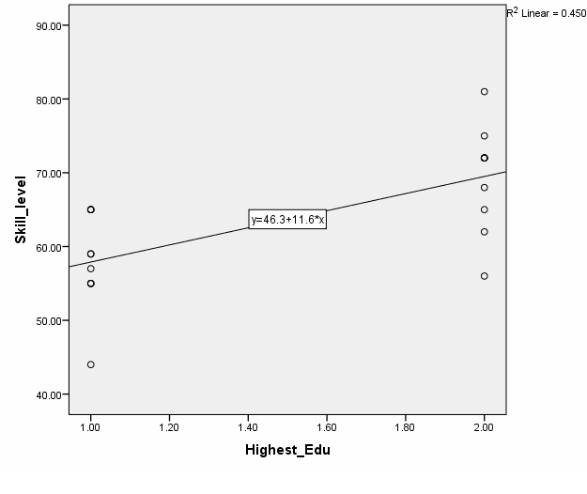

Figure 1: Correlation between skill level of a meditator and highest educational achievement

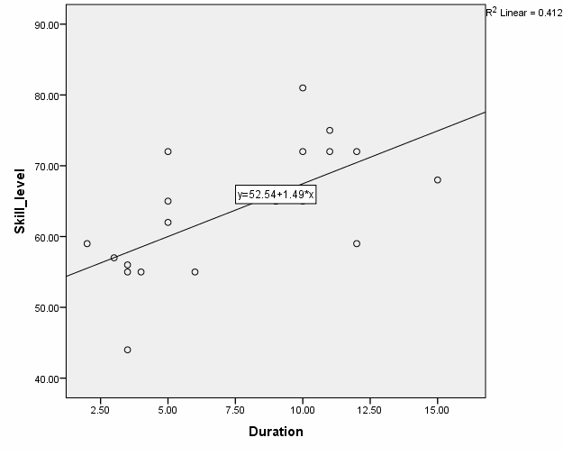

Figure 2: Correlation between skill level of a meditator and the duration of meditation practice in years.

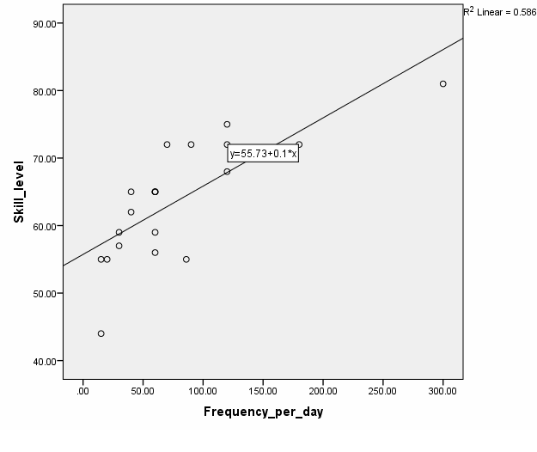

Figure 3: Correlation between skill level of a meditator and meditation frequency per day (in minutes)

Tables

Table 1: Correlation between skill level and age, gender, body mass index (BMI), diet type, number of sleeping hours, duration of the meditation practice, and frequency of meditation per day

 | Pearson correlation | Significance
Gender | 0.229 | 0.331
Age | 0.09 | 0.705
BMI | -0.097 | 0.683
sleeping hours per day | -0.146 | 0.604
Diet type | -0.058 | 0.809
Highest educational achievement | 0.671 | 0.001
Duration of the meditation practice | 0.642 | 0.002
Frequency of the meditation practice per day | 0.792 | <0.001

References

Alda, M., Puebla-Guedea, M., Rodero, B., Demarzo, M., Montero-Marin, J., Roca, M., & Garcia- Campayo, J. (2016). Zen meditation, Length of Telomeres, and the Role of Experiential Avoidance and Compassion. Mindfulness, 7(3), 651–659. https://doi.org/10.1007/s12671-016-0500-5
Amihai, I., & Kozhevnikov, M. (2015). The Influence of Buddhist Meditation Traditions on the Autonomic System and Attention. 2015. https://doi.org/10.1155/2015/731579
Bassetti, C. L. (2005). Sleep and Stroke.
Benson, H.; Rosner, B. A.; Marzetta, B. R.; Klemchuk, H. P.Decreased blood pressure in borderline hypertensive subjects who practiced meditation. J. Chron. Dis. 27:163-171; 1974
Bower JE, Crosswell AD, Stanton AL, et al. Mindfulness meditation for younger breast cancer survivors: a randomized controlled trial. Cancer. 2015; 121(8):1231–1240. [PubMed: 25537522]
Cahn, B. R., & Polich, J. (2006). Meditation states and traits: EEG, ERP, and neuroimaging studies. Psychological Bulletin, 132(2), 180–211. https://doi.org/10.1037/0033-2909.132.2.180
Conklin, A. Q. A., Crosswell, A. D., Saron, D., & Epel, E. S. (2018). Meditation, Stress Processes, and Telomere Biology. Current Opinion in Psychology. https://doi.org/10.1016/j.copsyc.2018.11.009
Cooper, M. J.; Aygen, M. M. Effects of meditation on serum cholesterol and blood pressure. J. Isr. Med. Assoc. 95:1-2; 1978.
Conklin, Q. A., King, B. G., Zanesco, A. P., Lin, J., Hamidi, A. B., Pokorny, J. J., … Saron, C. D. (2018). Insight meditation and telomere biology: The effects of intensive retreat and the moderating role of personality. Brain, Behavior, and Immunity, 70, 233–245. https://doi.org/10.1016/j.bbi.2018.03.003
Creswell, J. D., Irwin, M. R., Burklund, L. J., Lieberman, M. D., Arevalo, M. G., Ma, J., … Cole,
S. W. (2013). Mindfulness-Based Stress Reduction Training Reduces Loneliness and Pro-Inflammatory Gene Expression in Older Adults: A Small Randomized Controlled Trial. 26(7), 1095–1101. https://doi.org/10.1016/j.bbi.2012.07.006.Mindfulness-Based
Dada, R., Kumar, S. B., Bisht, S., & Khan, S. (2016). Oxidative Stress Induced Damage to Paternal Genome and Impact of Meditation and Yoga - Can it Reduce Incidence of Childhood Cancer ? (November).
Daniel J. Gottlieb, Naresh M. Punjabi, Ann B. Newman, Helaine E. Resnick, Susan Redline, Carol
M. Baldwin, J. N. (2005). Association of Sleep Time With Diabetes Mellitus and Impaired Glucose Tolerance. 165.
Deegalle, M. (2017) ‘Theravada Buddhism, Interreligious Philosophical Dialogues’,doi: 10.4324/9781315115474.
Duraimani, S., Schneider, R. H., Randall, O. S., Nidich, S. I., Xu, S., Ketete, M. Gaylord-king,
C. (2015). Effects of Lifestyle Modification on Telomerase Gene Expression in Hypertensive Patients : A Pilot Trial of Stress Reduction and Health Education Programs in African Americans. 1–18. https://doi.org/10.1371/journal.pone.0142689
Goldstein, M. (1999). ‘Alternative health care’. Philadelphia: Temple University Press.
Goldstein, C. A., & Smith, Y. R. (2016). Sleep , Circadian Rhythms , and Fertility. Current Sleep Medicine Reports, 206–217. https://doi.org/10.1007/s40675-016-0057-9
Happe, Svenja, Excessive Daytime Sleepiness and Sleep Disturbances in Patients with Neurological Diseases, 2003. Drugs; vol 63; 2725-2737 [https://doi.org/10.2165/00003495-
200363240-00003]
Hoge, E. A., Chen, M. M., Orr, E., Metcalf, C. A., Fischer, L. E., Pollack, M. H., … Simon, N. M. (2013). Loving-kindness meditation practice associated with longer telomeres in women. Brain, Behavior, and Immunity, 32(April), 159–163. https://doi.org/10.1016/j.bbi.2013.04.005
Jacobs, T. L., Epel, E. S., Lin, J., Blackburn, E. H., Wolkowitz, O. M., Bridwell, D. A., Saron, C. D. (2010). Intensive meditation training , immune cell telomerase activity , and psychological mediators. Psychoneuroendocrinology. https://doi.org/10.1016/j.psyneuen.2010.09.010
Le Nguyen, K. D., Lin, J., Algoe, S. B., Brantley, M. M., Kim, S. L., Brantley, J., Fredrickson, B. L. (2019). Loving-kindness meditation slows biological aging in novices: Evidence from a 12- week randomized controlled trial. Psychoneuroendocrinology, 108(May), 20–27. https://doi.org/10.1016/j.psyneuen.2019.05.020
Levine, G. N., Lange, R. A., Bairey-Merz, C. N., Davidson, R. J., Jamerson, K., Mehta, P. K., Smith, S. C. (2017). Meditation and cardiovascular risk reduction a scientific statement from the American Heart Association. Journal of the American Heart Association, 6(10), 1–14. https://doi.org/10.1161/JAHA.117.002218
Malarkey WB, Jarjoura D, Klatt M. Workplace based mindfulness practice and inflammation: a randomized trial. Brain Behav Immun. 2013; 27(1):145–154. [PubMed: 23078984]
Mendioroz, M., Puebla-guedea, M., Montero-marín, J., Urdánoz-casado, A., Blanco-luquin, I., Roldán, M.,García-campayo, J. (2020). Telomere length correlates with subtelomeric DNA methylation in long-term mindfulness practitioners. 1–12. https://doi.org/10.1038/s41598-020- 61241-6
Najib T. Ayas; David P. White; JoAnn E. Manson; Meir J. Stampfer, DrPH; Frank E. Speizer; Atul Malhotra, F. B. H. (2003). A Prospective Study of Sleep Duration and Coronary Heart Disease in Women. 163.
Perla Kalimana, 1, María Jesús Álvarez-Lópeza, b, Marta Cosín-Tomása, b, Melissa A. Rosenkranzc, d, Antoine Lutzc, d, e, and Richard J. Davidsonc, d, F. (2015). Rapid changes in histone deacetylases and inflammatory gene expression in expert meditators Perla. 96–107. https://doi.org/10.1016/j.psyneuen.2013.11.004.Rapid
Pipe, T. B., Bortz, J. J., & Cn, A. (2009). Nurse Leader Mindfulness Meditation Program for Stress Management A Randomized Controlled Trial. 39(3), 130–137.
Puhlmann, L. M. C., Valk, S. L., Engert, V., Bernhardt, B. C., Lin, J., Epel, E. S., … Singer, T. (2019). Association of Short-term Change in Leukocyte Telomere Length With Cortical Thickness and Outcomes of Mental Training Among Healthy Adults A Randomized Clinical Trial. 1–16. https://doi.org/10.1001/jamanetworkopen.2019.9687
Ramaswami, S., & Sheikh, A. (1989). Meditation east and west. In A. A. Sheikh & K. S. Sheikh (Eds.), Eastern and Western approaches to healing: Ancient wisdom and modern knowledge (p. 32). New York: Wiley & Sons.
Singh, N., Sharma, H., &Datta, P. (1997). ‘Gene Expression Profiling in Practitioners of SudarshanKriya Introduction’, 50–53.
Tolahunase, M., Sagar, R., & Dada, R. (2017). Impact of Yoga and Meditation on Cellular Aging in Apparently Healthy Individuals : A Prospective , Open-Label Single-Arm Exploratory Study. 2017.
van Genderen ME, Lima A, de Geus H, et al. Serum C-reactive protein as a predictor of morbidity and mortality in intensive care unit patients after esophagectomy. Ann Thorac Surg. 2011; 91(6):1775–1779. [PubMed: 21531378]
Wallace, R. K., Benson, H., and Wilson, A. F. (1971). A wakeful hypometabolic physiologic state. Amer.J. Phvsiol. 221, 795-799.
Xavier Pi-Sunyer, The medical risks of obesity, Postgrad Med. 121(6): 21-33. 2009 doi: 10.3810/pgm.2009.11.2074.
Yates, J., Immergut, M. and Graves, J. (2017) The Mind Illuminated: A Complete Meditation Guide Integrating Buddhist Wisdom and Brain Science for Greater Mindfulness. NY: Touchstone.

Acknowledgement
This research was supported by the Accelerating Higher Education Expansion and Development (AHEAD) Operation of the Ministry of Higher Education funded by the World Bank (Grant No. 6026-LK/8743-LK)

