ISSN 2012-9912 © The Open University of Sri Lanka 1

THE IMPACT OF THE TRAINING SETTING ON TEACHER TRAINEE DEVELOPMENT

B.M.S.S. Balasooriya*

Sri Lanka Institute of Advanced Technological Education

INTRODUCTION
This study examines the nature of the training setting in connection to the development of teacher trainees. Amongst the multiple factors that have an impact on the development of teacher trainees during the training, the work environment of the training setting is of vital importance. Therefore, the fundamental aim of the present study is to investigate the role of the work environment of the training setting in the prospective development of teacher trainees. This is achieved by analyzing the training settings of Higher National Diploma in English (HNDEn) teacher trainees in comparison with the Expansive-restrictive Framework introduced by Fuller and Unwin (2004).
Work-place influences on the performance and development of novice workers have been the subject of several studies (Fuller and Unwin, 2003, 2004, 2010; Atkinson, 2014; Kraft and Papay, 2014; Goddard and O'Brien, 2003; Nanayakkara, Neumann, and Pohlenz,2006) related to the areas on the suitability of the nature of workplace to different levels of workers, and beginning teachers’ perceptions of the work and quality assurance in Sri Lankan teacher training. Expansive-restrictive (ER) framework is a conceptual framework developed by Fuller and Unwin (2003) considering the diversity of working environments in the form of a continuum. This identifies a range of pedagogical and organisational factors that are categorized in two different extremes in terms of the learning of the worker (Figure 01). This continuum provides a framework for analysing workplaces as learning environments presenting expansive and restrictive features. The fundamental conclusion they have made is that rather than restrictive environments, expansive environments in an organisation foster both learning at work and integration of personal and organisational development (Fuller & Unwin, 2004). According to the researchers, the productive systems of workplaces lead to different forms of knowledge creation and different forms of learning and pedagogical approaches (Fuller et al., 2007). Though the contextual frame of this study is confined to the public and private sector organisations in the UK, the findings on the expansive-restrictive continuum make implications in the educational field too. The current study being an investigation of the professional development of teacher trainees, the studies by Fuller and Unwin (2003 and 2004) provide insight into the nature of the impact of the workplace on trainee professional development.
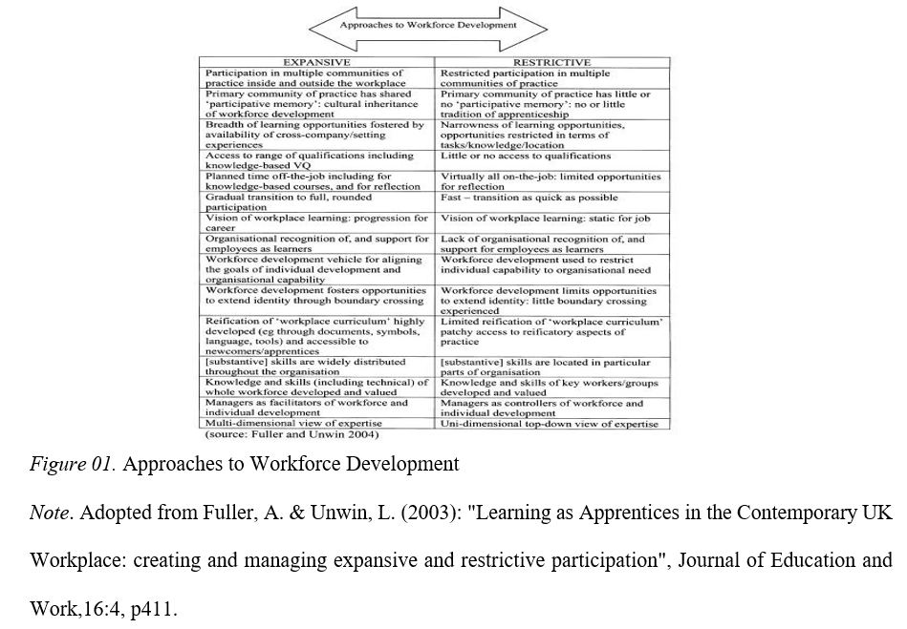

The expansive-restrictive nature is closely scrutinized in the work environment of training settings provided for the HNDEn teacher trainees during their practicum. HNDEn is a program which is conducted by Sri Lanka Institute of Advanced Technological Education (SLIATE) under the purview of the Ministry of Higher Education. It consists of two years of course work and a six-month teaching internship to produce knowledgeable, skilled, and professionally competent diplomates. The internship is particularly designed to prepare the teacher trainees for an upcoming career as a teaching professional introducing them to potential future work environments in schools.
In compliance with this purpose, trainees are expected to achieve professional proficiency by exposing themselves to the natural work settings in the Sri Lankan schools. But this expectation is not achieved in its entirety due to the perceived lack in the trainees’ development in learning and knowledge acquisition throughout the practicum. Hence, the research problem of the present study is the lack of learning and acquisition exhibited by teacher trainees during training. This problem is examined by investigating the impact of the expansive-restrictive nature of the training setting on the development of teacher trainees.
Therefore, the main objective of the study is to explore the learning development of teacher trainees fostered by the training setting with the following specific objectives formulated in line with the ER Framework.
- To examine how the opportunities are exploited by the teacher trainees in moving in multiple communities of practice.
- To study the degree of access to learning and acquisition available for the trainees in the training setting.
- To identify the opportunities available for the teacher trainees to gain other academic qualifications during training.

METHODOLOGY
The nature of the study is exploratory as it examines the work-place learning experiences of teacher trainees who follow the HNDEn programme conducted by the Advanced Technological Institute, Kurunegala functioning under SLIATE. Therefore, the qualitative approach was adopted, and the research was designed using the case study methodology.
The study population consisted of 90 interns who were undergoing the HNDEn teaching internship component for the stipulated period of six months covering six credits in 540 hours as partial fulfilment of the program. A purposive sample comprising 20 teacher trainees from the total population was employed to obtain data. Semi-structured interviews were conducted with the participants of the study as the method of data collection to gather qualitative data from the sample. The interview protocol included questions related to the nature of the work environment of the schools where they were placed for the training. Analysis of the qualitative database was performed utilising thematic analysis technique. Emerging themes were examined in the light of the ER Framework by Fuller and Unwin (2004).

RESULTS AND DISCUSSION
ER framework introduces the workplace as a learning environment. The present study adheres to the initial ER framework (2004) incorporating the features of an organisational learning culture (Table 01) in analyzing the learning experiences of teacher trainees. The expansive- restrictive features identified in three major areas are employed in the study in line with the research objectives so that it provides a firm ground for the analysis of the themes emerging from the experiences of the participants.

Opportunities to move in multiple communities of practice
The utility of opportunities available to move in multiple communities of practice in the training setting is investigated.
There are opportunities to move in multiple communities of practice in the training schools. The themes related to this aspect disclose the opportunities available for getting advice from colleagues working in the same school, keeping in touch with colleagues in other schools,

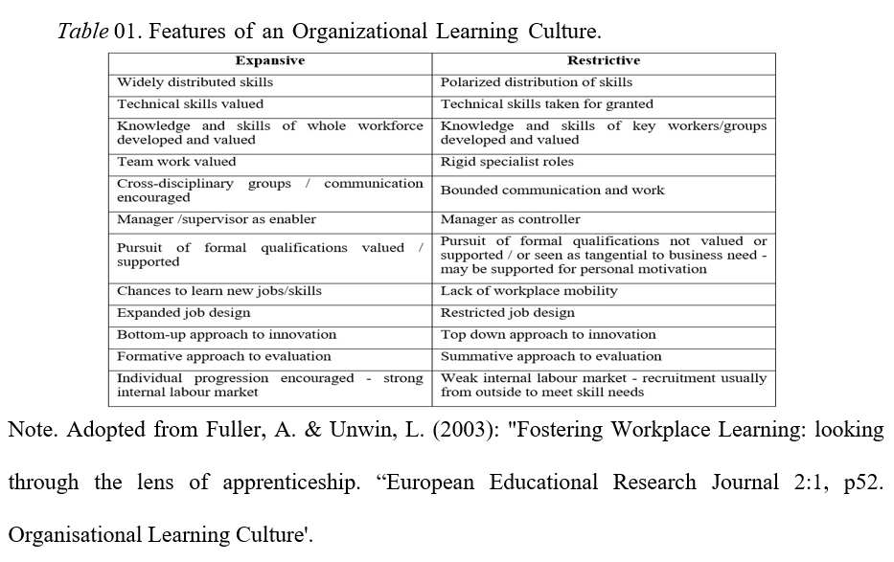

being exposed to the evaluation sessions by the authorities of zonal and provincial education offices and establishing a good relationship with students. The utility of the opportunity of moving with colleagues both in and outside of the current training setting provides the HNDEn trainees with an expansive working environment. Further, they are exposed to external situations of seminars, workshops, learning camps, and sports events, which allows them to extend their identity, crossing the boundary of the current training school. Hence, fostering access to learning by cross-company experiences as indicated by the ER framework.
Access to learning & acquisition
HNDEn teacher trainees’ access to learning and acquisition in the training setting is scrutinized drawing a comparison with the ER framework.
In line with the themes that arise from the data, trainees seem to achieve widely distributed skills rather than polarized distribution of skills in the areas concerning classroom management techniques, methods of instructional delivery, language skills. Moreover, most of their skills are valued by the supervisor, principal, and peer teachers. Rather than imposing rigid specialized rules on the role of the trainee in the school environment, they are made to work in teams collaborating with peer teachers, mentors, pupils, and the parents, which indicates the expansive aspect of the ER framework. Trainees admit that they get opportunities to receive others’ comments on their performance, which fosters learning from their colleagues. However, the restrictive nature in the workplace is implicit in the perceived belief of the trainees that they cannot learn the job only by working closely with their colleagues.
The manager or the supervisor is defined as an enabler in an expansive environment. HNDEn trainees find their mentor and/or the principal to be career-supportive in many respects including the evaluation of the progress and discussion of development needs providing continuous feedback. “My supervisor teacher is very much alert on my works. She’s observing my classes every day and checks my lesson plans and activities every day after the class”. The mentor in the training school setting does not manifest the role of a controller. The role of the trainee is not pre-defined at the commencement of the training. Therefore, they are exposed to diverse training environments that require them to produce multi-faceted works, including involvement in the teaching-learning process, co and extracurricular activities of the school, evaluation process, counselling, and documentary works related to school administration. Hence, the job design of a trainee is expanded rather than restricted in terms of ER features. In most situations, the trainee is independent of duty frame which leads to innovations in teaching methods and organising the own works on a priority basis, which is indicative of the bottom-up approach to innovation. This is hindered in situations where the trainee is barred from the choice of tackling a problem arising in the setting.

ISSN 2012-9912 © The Open University of Sri Lanka 3

Opportunities for other academic qualifications
Trainees are challenged by the requirement of gaining academic qualifications in the training setting. Though they expect the school authority to be responsible and supportive in the improvement of personal learning and development, the pursuit of formal qualifications is tangential in the fulfilment of the needs of the school. “There is too much workload for the teachers. They do not have time even to talk with a child. Lots of extra activities…”. Consequently, the trainees are not working towards any other qualification such as obtaining a degree, a diploma or enrolling for a short course, even if they believe in the necessity of achieving a qualification whether it is directly related to the job or not. This is indicative of the restrictive nature of the work environment. (Comparison of these findings with the ER framework is presented in Table 02).

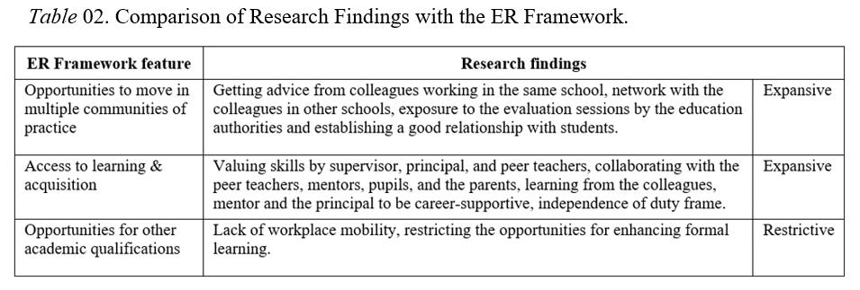

CONCLUSION/RECOMMENDATIONS
The work environment of the training settings of HNDEn teacher trainees is found to be expansive in the situations where it provides trainees with multiple opportunities for career development including moving in various communities of practice and access to learning and acquisition of new knowledge. Yet, the work environment is restricting the opportunities for enhancing the formal learning during training and the lack of workplace mobility which hinders the likelihood to learn new jobs and skills in the prevailing setting (Table 02).
Therefore, the work environment of the training schools is found to be less effective in functioning as healthy learning environments during the practicum. The restrictive nature of the work environment can be alleviated through constant monitoring of the trainees and generating motivation by way of that. The establishment of a monitoring system implemented on a regular basis is recommended to be imposed by the SLIATE authority to achieve the purpose.

REFERENCES
Atkinson, K. J. (2014) Does the concept of expansive-restrictive learning fit knowledge workers aged over 50? An examination of selected features and high-end knowledge workers in a UK public sector organisation. University of Leicester.
Fuller, A., & Unwin, L., (2003): Fostering Workplace Learning: looking through the lens of apprenticeship.
European Educational Research Journal, 2(1), pp 41-53.
Fuller, A., & Unwin, L., (2003): Learning as Apprentices in the Contemporary UK Workplace: creating and managing expansive and restrictive participation. Journal of Education and Work, 16(4), pp 407–426.
Fuller, A., & Unwin, L. (2004) 'Expansive learning environments: Integrating organizational and personal development' Chapter 8 in H. Rainbird, A. Fuller and A. Munro (eds). Workplace Learning in Context. London: Routledge, pp 126-144.
Fuller, A., & Unwin, L. (2010). Workplace learning and the organization. The Sage Handbook of Workplace Learning. 46-59. Retrieved from 10.4135/9781446200940.n4.
Goddard R., & O'Brien P. (2003) Beginning Teachers' Perceptions of Their Work, Well-being, and Intention to Leave.
Kraft M. A., & Papay J. P. (2014) Can Professional Environments in Schools Promote Teacher Development? Explaining Heterogeneity in Returns to Teaching Experience. Educational Evaluation and Policy Analysis, Vol. 36, No. 4, pp. 476-500. American Educational Research Association.
Nanayakkara S. L. G., Klaus D., Neumann K.D., & Pohlenz P. (2006), Quality Assurance in Sri Lankan Teacher Training. Retrieved from https://www.researchgate.net/publication/237723432

