GAME BASED LEARNING APPROACH FOR VIRTUAL PROGRAMMING LABORATORY CLASSES

S. N. Perera1, S. Rajasingham2

1 The Department of Computer Science, The Open University of Sri Lanka
2 Centre for Education Technology and Media, The Open University of Sri Lanka

INTRODUCTION
The exponential growth in technology has triggered the development of cutting-edge technologies that can be embedded in various fields. Education has been one such sector that has automated the traditional pedagogical approach into online teaching. Even though the benefits of online learning are encouraging, there exists a certain degree of resistance with respect to this practice in the broader community mainly due to sustaining intrinsic and extrinsic motivation of students engaging in online programs, bridging the gap in between student-teacher interaction and promoting subject specific knowledge. Although considerable research has been devoted to game-based e-learning to increase users’ motivation, experience and engagement, less attention has been paid to online learning for programming courses. There exist some popular e-learning platforms such as Moodle, Expertus, Top Hat, Canvas etc., however, they lack support in providing interactive programming learning experiences for students.
The Open University of Sri Lanka (OUSL) is the only exclusively Open and Distance Learning (ODL) higher educational institute in Sri Lanka. Currently, the institute uses an open source Learning Management System (LMS) which plays a major role in fulfilling technical requirements for online teaching and learning of courses under three main categories: supplementary, blended and fully online. Although the convenience and the pervasive use of online learning platforms seem extremely popular there still exists a group of individuals that consciously stayed away due to the challenges posed in the online learning process. However, the COVID-19 situation compelled the immediate transformation of traditional learning to online learning around the world which forced even the practical programming laboratory sessions to be conducted via e-learning platforms. This approach posed extreme challenges as the existing e-learning platform did not support the practical programming component. During the COVID-19 pandemic period, the current platform was ill-equipped to deliver all the programming practical courses online with the sudden complete shutdown of universities around the country. The transition of face to face laboratory classes to fully online sessions is not an easy task where they have to ensure the success of delivering material by confirming that the students absorb it.
Digital games are playing vital roles in students' learning experience. Evolution of technology in game-based learning has been used as excellent tools for increasing participation, engagement, loyalty, and competition among students. Gamification in learning and education is a set of activities and processes to solve problems related to learning and education by using or applying the game mechanics in non-game applications (Kim et al., 2017).
There exists much research that focuses on game-based learning to improve the interactive engagement for a subject specific learning environment. The authors (Cheng & Su, 2012) have developed the game-based learning platform to enhance self-efficacy for students’ learning for a subject that is specifically designed for theoretical aspects which lacks the essence for conducting laboratory practical programming sessions. In paper (Hooshyar et al. 2016) have emphasised the importance of having a game-based component in the learning platform that was used for the students. The experiment results have proved the enhancement of student’s learning interest, attitude, and problem-solving capabilities. Although the system shows an impact on the students’ logical aspect of problem-solving capabilities it does not address the practical aspect of the concepts included in the programming language. In literature (Mathrani et al, 2016; Rugelj & Lapina 2019); Rajaravivarma (2005); Shahid, (2019)] it has been proved that the extensive use of game based techniques and elements in

learning platforms have been effective among students especially for programming related curriculum. The complex, tedious and logical thought-provoking aspects in the programming language curriculum can be easily mapped to the game based elements to sustain students’ involvement, learning interest, understanding and enhancing problem solving capabilities of the
subject matter.
This paper introduces a study that includes a game based interactive activity that is subject specific to programming language and a questionnaire to evaluate the level of motivation and involvement in attempting the game based interactive activity. The purpose of this study is to find the possibility of motivating and stimulating learners towards laboratory sessions in a virtual programming laboratory environment via game-based elements. This is a progressive approach that encourages the development of fruitful strategies that sustains the engagement of students in a virtual programming laboratory environment via game based elements that includes awarding badges, recognizing achievement, maintaining leader boards and designing
levels triggering competitive and comparative streaks to achieve educational benchmarks.

METHODOLOGY
The experiment includes students (n = 200) enrolled in the first year of the Bachelor of Technology (BTech) programme for programming language. These students participated in a game-based interaction platform to attempt the practical sessions in which they were asked to complete certain levels to comply with the curriculum. The games were developed where students would be able to choose a role with different capabilities and engage in the game towards the victory. The game consists of levels and always helps with hints to help students when they get stuck. Once completed with all the levels, students would be able to apply the coding skills which they have learnt in the real coding environment. A questionnaire was also designed to extract the comparison of the involvement and the interest level between the traditional face to face learning and game based interactive session. Upon completion of the respective activities, the students were presented with the above mentioned questionnaire that was designed to reflect and quantify their overall experience, level of involvement, understanding of the subject matter and the learning interest between the traditional face to face setup and the game based interaction platform that was presented to the students. This study analyses the level of achievement and engagement in the game based interactive set up for the programming course to evaluate the significance of achievements of the students.

RESULTS
The results depicted in the following charts were extracted from the survey results presented to the students. The experience and the level of involvement were quantified and presented in the following figures.
Figure 1 shows the enjoyment of the participants in the interactive programming laboratory sessions. The results show that 45% of the students agree and 25% strongly agree. This shows that 70% of the participants are enjoying the game based interactive session.
Figure 2 shows the confidence level in basic programming after attempting the online game based interactive session. The results show that 55% of students stated good while 20% stated excellent. The results show that the 75% of the participants have higher confidence level in the online game based interactive session.
Figure 3 shows that the level of understanding in the basic programming after attempting the online game based interactive session. The results show that the 45% of students stated good while 30% stated excellent. The results show that the 75% of the participants have better understanding of the knowledge acquired in the online game based interactive session.

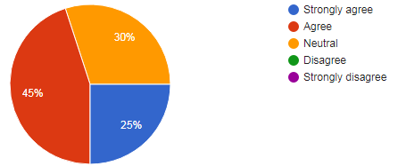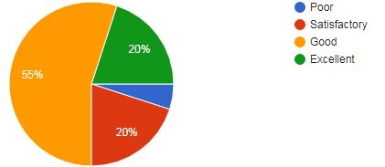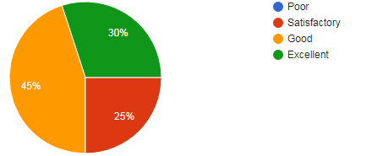
Figure 1: Enjoyed participating in the interactive programming laboratory session
Figure 2: Confidence level in the interactive programming laboratory session
Figure 3: The level of understanding in the interactive programming laboratory session

Figure 4 shows that the level of satisfaction with the current set up of the lab practical for the programming courses. The results show that only 30% of students are satisfied, 45% stated somewhat satisfied and 5% are dissatisfied. The results show that most of the participants are expecting an improvement with the current traditional laboratory setup.
Figure 5 shows that the preference of interactive game-based session has a higher demand than the traditional laboratory setup. The results show 75% of demand for the online game based interactive laboratory session while 25% for the traditional laboratory setup.

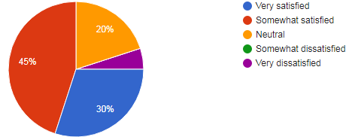
Figure 4: The level of satisfaction with the current set up of the laboratory practical for the programming courses

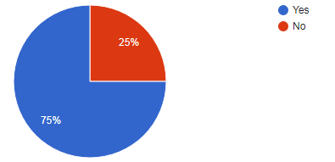
Figure 5: The preference of programming language course in the interactive game-based setup

DISCUSSION
We can compare these results with the traditional programming laboratory because these students who attempted the interactive session are students who have been enrolled in lab classes that are involved in the traditional programming laboratory environment. Hence the results can be deduced as a comparison of the traditional programming environment and the interactive game-based setup.
The Fig. 1, 2, 3 and 4 show that compared to the traditional programming environment that the participants have experienced in their previous lab session while enrolled in the courses they show increased enjoyment, high confidence and increased understanding in the interactive game-based setup rather than that of the current setup practiced. Also, in Fig. 5 preference level of the respective language shows that there is a higher preference rate for the interactive game-based setup. Therefore, this shows that there is an increase in preference level in conducting the laboratory session in the interactive game-based setup than that of the traditional programming environment.

CONCLUSIONS/RECOMMENDATIONS
The game-based interaction system extensively enhanced students’ level of involvement, understanding of the subject matter and the learning interest. The students who attempted the survey and the respective approach are following courses that are based on practical from a traditional learning environment. Hence attempting the interactive game-based approach has given students the opportunity to compare this approach with the traditional programming environment. According to the results, the game-based learning environment can stimulate and motivate students more than the traditional learning environment. This study shows that there is a preference level that is towards the game-based approach rather than the traditional learning environment which shows that there is a need to incorporate game-based

learning elements to the current LMS for programming practical laboratory sessions conducted in the OUSL.

REFERENCES

Cheng, C. H., & Su, C. H. (2012). A Game-based learning system for improving student's learning effectiveness in system analysis course. Procedia-Social and Behavioral Sciences, 31, 669-675.

Hooshyar, D., Ahmad, R. B., Yousefi, M., Fathi, M., Horng, S. J., & Lim, H. (2016). Applying an online game-based formative assessment in a flowchart-based intelligent tutoring system for improving problem-solving skills. Computers & Education, 94, 18-36.

Kim, S., Song, K., Lockee, B., & Burton, J. (2018). What is gamification in learning and education? In Gamification in learning and education (pp. 25-38). Springer, Cham.

Mathrani, A., Christian, S., & Ponder-Sutton, A. (2016). Play IT: Game based learning approach for teaching programming concepts. Journal of Educational Technology & Society, 19(2), 5-17.

Rajaravivarma, R. (2005). A games-based approach for teaching the introductory programming course. ACM SIGCSE Bulletin, 37(4), 98-102.

Rugelj, J., & Lapina, M. (2019). Game design-based learning of programming.

Shahid, M., Wajid, A., Haq, K. U., Saleem, I., & Shujja, A. H. (2019, November). A review of gamification for learning programming fundamental. In 2019 International Conference on Innovative Computing (ICIC) (pp. 1-8). IEEE.

