STRUCTURAL UPGRADING OF EXISTING RAILWAY TURNING TABLES IN SRI LANKA

M.T. Pratheepan, T. Hamsathpriyan, P.A.K. Karunananda*

Department of Civil Engineering, The Open University of Sri Lanka

INTRODUCTION

The turning table was first introduced in England in 1839 and over the next century it became popular and regularly used in railway systems in worldwide. A railway turning table is basically a bridge structure rotating in the horizontal plane to change the direction of railway engines as illustrated by Walthers (2018). The many types of turning tables have been introduced in worldwide from the past. However, the most common type ‘Continues girder type’ was constructed in Sri Lanka and all of these structures are either 55’ or 60’ in length and designed for steam engine weight for 45 tons as introduced by Silva (2014). Modernly used diesel engines have higher weight than steam engines. The modern engines can be controlled in both sides, but driver cabin located in one end. For increasing the short distance sight view, the engine must be turned, thereby be able to minimize accidents during travelling in forestry, upcountry sides, and bad weather conditions.

The turning table structure which is situated in the circular pit relates to center pivot in middle and it helps to turning table to rotate as shown by Hollingsworth (1980). In the existing turning table structure, it has an allowable end deflection range between the clear distance of ring rail and end bearing wheels for steam engines weight nearly 45 tons. According to the design of continuous girder types, before loading the gap should be 1 inch between circular track and bearing wheels, and, after the loading the gap should be in minimum 3 to 5mm between them, which allows the engines freely rotate. When using diesel engines in the existing tables the structure exceeds its allowable end deflection, and this allows the bearing wheels to forcedly touch with circular track and difficulty in rotation. These actions lead the railway turning table structure to service failure for heavier diesel engines. Further increase of locomotive engine weights causes other technical issues such as exceedance of soil bearing capacity and entre pivot capacity. However, the issue related with end deflection was only focused in this study. Therefore, the aim of this paper is to avoid the service failure and make free to rotate without any obstacles while reducing the edge deflection, Figure 1 shows the presently used turning table. Figures 2 and 3 shows the schematic view of main girder of 55’, and 60’ long turning tables.

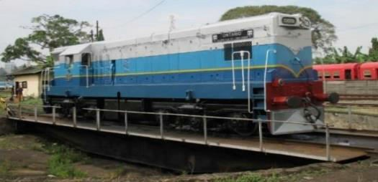End bearing wheel
Main girder

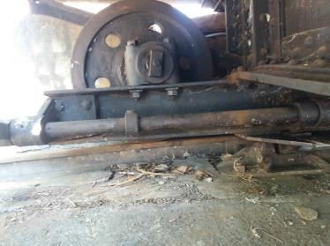Ring rail and circular track

Figure 1: Existing Continuous Girder Type Turn table

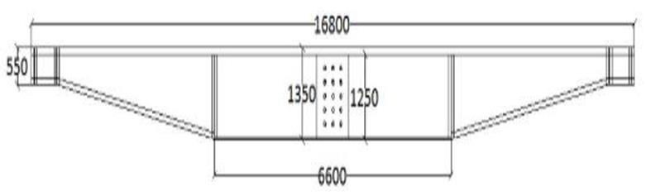

Figure 2: A sectional view of the main girder of 55’ long turning table (dimensions are in mm)

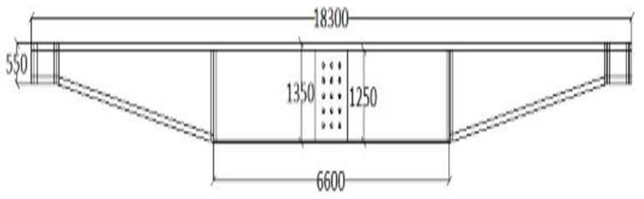
Figure 3: A sectional view of the main girder of 60’ long turning table (dimensions are in mm)
METHODOGOLY

3D numerical models of the 55’ and 60’ long turning tables were prepared using SAP2000 v.14 general purpose software package. Figure 4 shows the developed numerical model for 55’ long turning table. The center was pinned supported and the end was made as a free support. The loads coming from various train engines (steam, 6 nos. of M class engines) were applied as point loads on to the two main girders and internal force output was determined. Figure 4 shows the developed numerical model. Moment and shear capacities of the numerical model were obtained and compared with code given values. It was understood that both shear and moment capacity are within allowable range. End deflection values were compared with actual field deflection values, obtained from the dial gauge measurements. Excessive end deflection is the only concern in these structures.

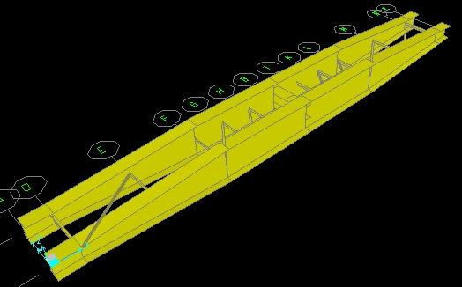

Figure 4: Prepared numerical model of 55’ long turning table

With above findings, following two options were proposed to reduce the end deflection to a n allowable limit.

Option -1 Increasing stiffness of the Main girder or structure by “Adding Side ‘C’ Section”, From this option, it can increase the web, top flange, and bottom flange thickness.

Option -2 Increasing stiffness of the main girder or structure by “Increasing Top flange thickness”, from this option, it can increase only top flange thickness.
The option 1 and 2 were applied for 55’ and 60’ long turning tables by using new numerical Models prepared using SAP2000 v.14 software and compared with actual deflection of turning tables. According to the result the option 1 is suitable for length 55’ turntable, and option 2 for length 60’ turning table. Table 1 describes the summary of the results, where the actual, option
-1 and option -2 end deflections was under discussion.

Table 1 - Summary of Models (End Deflections)

Engine type | load (Ton) | End Deflection (mm) |  |  |  |  |  | Effectiveness of strengthening results (%)
 |  | Existing structure |  | Option 1 |  | Option 2 |  | Option 1 |  | Option 2
 |  | 55 ft turn table | 60 ft turn table | 55 ft turn table | 60 ft turn table | 55 ft turn table | 60 ft turn table | 55 ft turn table | 60 ft turn table | 55 ft turn table | 60 ft turn table
Steam | 45 | 8.71 | 10.07 | currently not use |  |  |  | currently not use
M2 | 79 | 23.36 | 33.97 | 5.00 | 9.79 | 9.52 | 13.20 | 78.60 | 59.25 | 71.98 | 61.14
M6 | 87 | 26.02 | 37.64 | 5.36 | 10.80 | 10.57 | 14.40 | 79.40 | 59.38 | 71.92 | 61.74
M4 | 93 | 28.17 | 39.85 | 7.22 | 11.54 | 11.33 | 15.30 | 74.37 | 59.78 | 71.57 | 61.61
M8 | 107 | 32.16 | 46.26 | 7.97 | 13.27 | 12.37 | 17.80 | 75.22 | 61.54 | 73.26 | 61.52
M10 | 120 | 34.62 | 51.71 | 12.95 | 14.91 | 13.92 | 20.04 | 62.59 | 59.79 | 73.08 | 61.25

CONCLUSION AND RECOMMENDATIONS
According to the results, shear capacity and moment capacity are satisfied as with BS5950 Part 1: 2000, However, the end deflection of the structure ranges are not satisfied because the clear distance not enough to adequate for bending. The introduction of two options/solutions for upgraded structure gives the satisfaction for the minimum requirement, the range of clear distance of end-deflection (< 25mm) between ring rail and end bearing wheels of railway turning tables. The results of end deflections were compared with existing and two options of upgraded models. According to the results of end deflection for the upgraded model satisfied optimum solution like range between 5 - 20.04 mm, and the stiffness of the upgraded structure is increased by 45.82 to 58.4 %. Thereby the increasing of structural stiffness is an appropriate suitable solution for current issue. According to economical point of view, the reconstruction causes more expenditure than modification. Therefore, upgrading the existing structure is the optimal solution.

The upgraded section for main girder makes it stiffer than earlier existing section. It may help to reduce the excess end deflection and provide easier operation of the railway turntables. A structural element should be adequate internal strength to resist loading conditions. When

increasing sectional properties (like option-1 and option-2) of main girder become stiffer than existing main girder, and it able to resist. The sectional properties are increased by two methods, while comparing with two methods, option 1(adding “C” Section) is more effective than option 2 for 55’ turning table and option 2(Increasing top flange) more effective than option 1 for 60’ turn table. The proposed methods for upgrading the turning table structure it can gives solution for current issue about turning table operations in Sri Lanka Railways.

REFERENCES
K. Walthers, (2018) “Modern turn table with DCC installation – BUILD UPS”, Inc., Milwaukee WI , 5328, corner stone series

Stephen De Silva, (2014): History of the Sri Lanka Government Railways

John Brian Hollingsworth, (1980) “Atlas of the world's railways”, Everest house.

Structural use of steel in building, Part 1 Code of Practice for Design rolled and welded sections
- BS5950 Code 1:2000.

