FEASIBILITY OF USING CRUSHED LIMESTONE TO PRODUCE CEMENT BLOCKS IN THE NORTHERN PROVINCE OF SRI LANKA

S. Kobithan, L. Rakulan, V. Panchapikesan, L.S.S. Wijewardena*

Department of Civil Engineering, The Open University of Sri Lanka

INTRODUCTION

Burnt clay bricks and cement blocks are the most widely used building blocks that are used to construct walls in Sri Lankan homes. Burnt clay bricks are not available in the Northern Province of Sri Lanka. As a result the main construction material is cement blocks. Even for the production of these conventional cement blocks, the main ingredient, quarry dust crushed from granite, needs to be transported over long distances as quarry dust is not available in the Northern Province. This results in the cement blocks being more expensive in the Northern Province than in other places of Sri Lanka.

The geological formation of the Northern Province of Sri Lanka is of a limestone rock origin (Cooray, 1984). As a result, aggregates crushed from granite, typically used for concrete and cement block production, are not available there. However, aggregates crushed from limestone, normally not used for engineering construction works, are freely and abundantly available there. As a solution to this high cost of conventional cement blocks, an experimental approach was designed and carried out to verify the suitability of using aggregates crushed from limestone to produce cement blocks.

Makhloufi et.al (2014) have used crushed limestone to replace fine aggregate in producing concrete together with a superplasticizer. They have achieved similar results with concrete produced with crushed limestone instead of using natural sand. Sivakumar et. al. (2018) have combined limestone dust together with saw dust to produce bricks.

Sri Lanka Standards Institution has published standards applicable to the requirements and test methods applicable to cement blocks (SLS 855: Parts 1 – 2, 1989). SLS 855 stipulates the requirements to be satisfied by cement blocks.

METHODOLOGY

In order to simulate the actual production process, a cement block making machine used by a commercial manufacturer of cement blocks was used to make blocks in this study using limestone aggregate. However, moulds of these machines fabricated by local manufacturers do not comply with any block size recommended in SLS 855: Part 1. The machine selected for this study produced blocks of size 300 x 100 x 150 mm suitable for single-storey houses.

SLS 855: Part 1 does not recommend any cement: aggregate mix proportion other than specifying the required compressive strengths. Table 6 of SLS 855: Part 1 specifies a minimum compressive strength of 1.20 N/mm2 for single storey houses for any block size. Further, since SLS 855 does not specify the curing period, the compressive strength of casted blocks was tested after 1, 14 and 28-day curing periods.

Commercial manufacturers of cement blocks use mix proportions up to 1: 12. Mageed and AbdelHaffez (2012) have used limestone dust in brick making and the mix proportion they have used is approximately 1: 7 to produce bricks satisfying Egyptian Standards. In order to determine the most economical cement: aggregate mix proportion to achieve the specified 1.2 N/mm2 compressive strength, cement blocks were cast using Ordinary Portland Cement (OPC),

as recommended in SLS 855, and limestone aggregate varying the mix proportion from 1:3 up to 1:9. A sieve analysis test was carried out, as specified in BS 882: 1992, to verify that the crushed limestone used, obtained from a local quarry, for making the blocks fall into the category of well-graded sand. Resulting particle size distribution curve is shown in Figure 1.

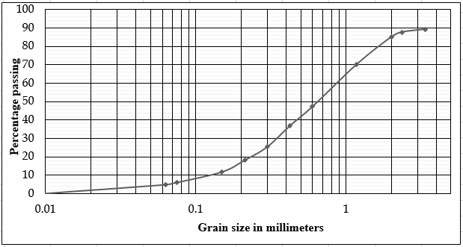
Figure 1 – Particle size distribution curve of crushed limestone

It can be seen from the particle size distribution curve that the coefficient of uniformity, Cu > 6 and coefficient of curvature, 1 < Cc < 3 and hence, the sand is well graded.

Drying shrinkage, wetting expansion, water absorption and moisture content determination tests were carried out on blocks cast with the optimum mix proportion in order to make sure the complete compliance with the SLS 855 requirements. Tests were carried out as specified in SLS 855: Part 2.

RESULTS AND DISCUSSION

Compressive strength

Results of the compressive strength test carried out after 1 day, 14 days and 28 days for different cement: aggregate proportions are plotted in Figure 2.

Since SLS 855 does not specify any specific curing period, the only requirement is that the specified 1.20 N/mm2 compressive strength should be achieved by the time the blocks carry the loads of the structure. Further, to prevent any damage to blocks during handling, the required strength should be achieved within a short duration. Hence, it is reasonable to take 7 days as the curing period and cement: aggregate ratios up to 1: 8 have achieved the specified strength by 7 days according to Figure 2. This makes the 1: 8 mix proportion the most economical out of the trials carried out. Subsequent tests were done only for blocks cast with cement: limestone aggregate mix proportion of 1: 8.

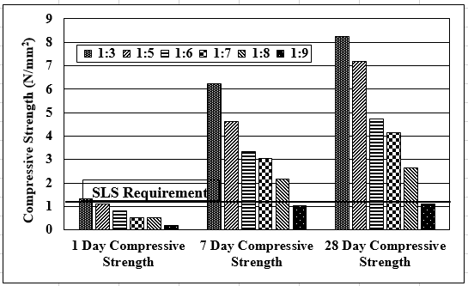

Figure 2 – Results of the compressive strength test for different mix proportions

Water absorption
The measured value of water absorption of crushed limestone cement blocks was 173.6 kg/m3. This is less than 240 kg/m3 specified in Table 4 of SLS 855: Part 1.

Moisture content
Table 4 of SLS 855 part 1 specifies an upper value of 40% for moisture content of cement blocks. Crushed limestone cement blocks recorded a moisture content of 6.9%, much less than 40%.

Drying shrinkage
Crushed limestone cement blocks achieved a drying shrinkage value of 0.055%. Table 4 of SLS 855: Part 1 specifies an upper value of 0.06%, very close to the observed value.

Wetting expansion
Similar to drying shrinkage, the measured value of wetting expansion of crushed limestone cement blocks was 0.029%, slightly less than the upper value 0.03%, specified in SLS 855: Part 1.

Cost analysis

A separate cost analysis carried out indicated that the crushed limestone cement blocks are 35% cheaper than the cement blocks produced using quarry dust crushed from granite. This is as expected since there is hardly any transport cost involved with crushed limestone compared to the cost of transporting crushed granite from North Central Province.

CONCLUSIONS / RECOMMENDATIONS

Based on the results obtained from this research study it can be concluded that crushed limestone, freely available in the Northern Province of Sri Lanka can be effectively used to produce cement blocks reducing the cost of blocks by 35% compared with using quarry dust crushed from granite transported from long distances to the Northern Province.

Produced blocks, satisfying all the requirements specified in SLS 855 for construction of single- storey buildings, were cast using a cement: aggregate ratio of 1:8 and should be cured for seven days before the application of structural loads.

SLS 855 does not specify any durability test on cement blocks. However, due to the vulnerability of limestone under harsh environmental conditions, it may be worth testing the durability of blocks made using limestone aggregate. However, this situation does not arise when blocks made with limestone aggregate are used to construct walls of single-storey dwelling unit.

REFERENCES

Specification for Cement Blocks - Sri Lanka Standard 855 (1989), Part 1: Requirements, Part 2: Test Methods, Sri Lanka Standards Institution

British Standards Institution – BS 882 (1992), Specification for aggregates from natural sources for concrete, British Standards Institution

Siva Kumar, K., Naziya, S., Ganesh, P, Prasanna Kumar, R. and Sai Raghuram Reddy, M. (2018) Limestone Dust and Wood Saw As a Brick Material. International Journal of Engineering Trends and Applications (IJETA) – Volume 5 Issue 2

Mageeda, A.A. and AbdelHaffez, G.S. (2012) Utilization of limestone dust in brick making. Journal of Engineering Sciences, Assiut University, Vol. 40, No. 3, pp. 913-922

Makhloufi, Z., Bouziani, T., Bédérina, M, and Hadjoudja, M. (2014) Mix proportioning and performance of a crushed limestone sand-concrete. Journal of Building Matererials Struct., (2014) 1: 10-22

Cooray, P.G. (1984) An introduction to the geology of Ceylon. National Museums of Sri Lanka, Sri Lanka

